***Datamining Report on***

***Big Black money dataset***

* **Introduction:**

**In the era of big data, analyzing and interpreting complex datasets has become increasingly challenging. Datamining is the process of discovering patterns, correlations and anomalies within large datasets to predict outcomes. It involves various techniques such as classification, regression, clustering, association rule learning and anomaly detection. These techniques help in extracting valuable insights and making data-driven decisions.**

**Following datamining, Data exploration involves examining the dataset to understand its structure, patterns, anomalies, often using summary statistics and visualizations. Data preprocessing prepares the raw data for analysis by handling missing values, encoding categorical variables, and detecting outliers, ensuring data quality and consistency.**

**Dimensionality Reduction Techniques, such as Principal Component Analysis (PCA) and t-Distributed Stochastic Neighbor Embedding(t-SNE), simplify large datasets by reducing the number of variables while retaining essential information. PCA transforms high-dimensional data into a lower-dimensional form, preserving variance, while t-SNE focuses on maintaining the local structure of the data, making it effective for visualizing complex patterns.**

**Finally, Cluster Analysis groups similar datapoints into clusters based on their characteristics, using algorithms like K-Means. This technique helps identify natural groupings in the data, providing valuable insights for various applications, from market segmentation to anomaly detection………**

* **Document structure:**
* **Report Requirements.**
* **Data Exploration:**
* **Overview of the dataset.**
* **Summary Statistics.**
* **Missing Values.**
* **Data Preprocessing:**
* **Data Cleaning.**
* **Data Transformation.**
* **Outlier Detection (in different ways).**
* **Encoding categorical Data.**
* **Standardize the Features.**
* **Insights from Exploratory Data Analysis (EDA): Data Visualization**
* **Univariate Analysis.**
* **Bivariate Analysis.**
* **Multivariate Analysis.**
* **Dimensionality Reduction:**
* **Principal component analysis (PCA).**
* **T-Distributed Stochastic Neighbor Embedding(t-SNE).**
* **Cluster Analysis:**
* **K-Means, Hierarchical Clustering.**
* **Evaluate and Interpret-Elbow Method or Silhouette Score.**
* **Decision Tree.**
* **Email Spam Filtration.**
* **Document Requirements:**
* **Dataset Name: Big Black Money Dataset.**
* **Source: Kaggle.**
* **Implementation: VS Code.**
* **Referenced Research Paper:** [**https://dea.gov.in/sites/default/files/WhitePaper_BackMoney2012_0.pdf**](https://dea.gov.in/sites/default/files/WhitePaper_BackMoney2012_0.pdf)
* **Introduction of Research Paper:**

**The research paper “White Paper on Black Money” published by the Government of India in 2012 addresses the issue of unaccounted wealth, commonly referred to as black money. It examines the sources and consequences of black money, outlining impact on the economy, governance, and society.**

1. **Definition and Sources: The paper defines black money and identifies its sources, including tax evasion, corruption, and illicit financial activities.**
2. **Economic Impact: It discusses how black money undermines legitimate economic growth, distorts financial markets, and contributes to inequality.**
3. **Legal Framework: The document reviews existing laws and regulations aimed at curbing black money black money and suggests improvements.**
4. **International Cooperation: Emphasizes the need for collaboration with other countries to combat cross-border tax evasion and illicit financial flows.**
5. **Policy Recommendations: Proposes measures for better enforcement of tax laws, strengthening institutions, and increasing transparency in financial transactions.**

**The paper aims to raise awareness and promote dialogue on the need comprehensive strategies to tackle the black money issue in india.**

* **Data Exploration:**

**Data Exploration is the initial step in the data analysis process, where we examine the dataset to understand its structure, patterns, and anomalies. This phase involves summarizing the main characteristics of the data, often using visual methods. The goal is to uncover insights, detect outliers, and identify relationships between variables. Key activities in data exploration including generating summary statistics, visualizing data distributions, and identifying missing values.**

**Load the Dataset: First, let’s load the dataset. Assuming you have it in a CSV file, you can use pandas to load it and display the first few rows which helps us to get quick look at the structure of the dataset.**

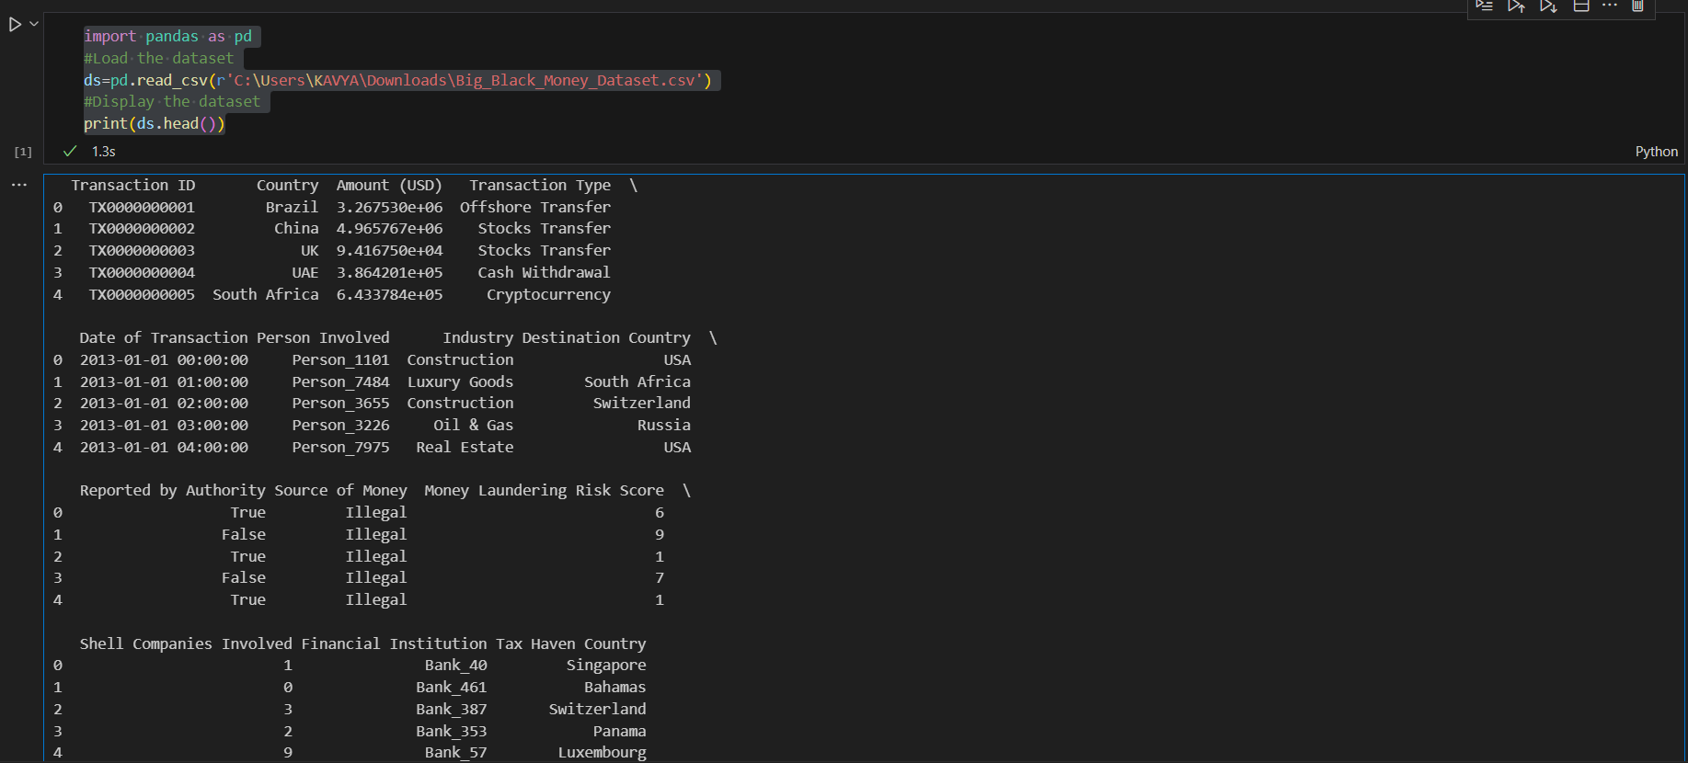

**Summary Statistics: Summary statistics provide a quick overview of the data’s central tendencies and variability. Key measures include the mean, which is the average value; the median, which is the middle value when the data is sorted; and the mode, which is the most frequently occurring value. Additionally, measures of dispersion such as range, variance, and standard deviation help to understand the spread of the data.**

* **The output provides summary statistics for three variables using describe () predefined function: ‘Amount (USD)’, ‘Money Laundering Risk Score’, and ‘Shell Companies Involved’. Here’s a breakdown of what each part means:**

**Count: The number of non-missing values for each variable.**

**Mean: The average value of each variable.**

**Standard Deviation (std): A measure of the spread or variability of the values.**

**Minimum (min): The smallest value in the dataset for each variable.**

**25% Percentile: The value below which 25% of the data falls.**

**50% Percentile (Median): The middle value of the dataset.**

**75% Percentile: The value below which 75% of the data falls.**

**Maximum (max): The largest value in the dataset for each variable.**

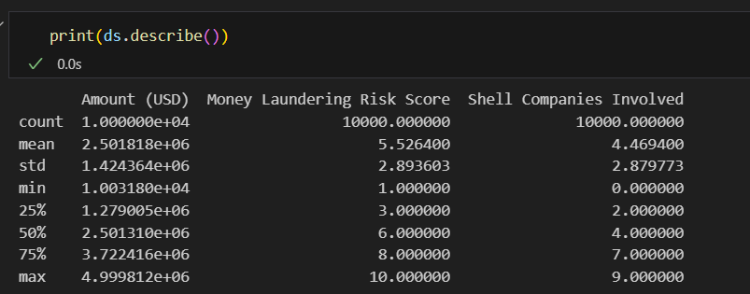

**Basic Information:**

**Basic information about a dataset includes the number of observations (rows) and features (columns), the data types of each column (e.g., integer, float, string), and the count of missing values in each column. This information helps in assessing the structure and quality of the data. (Use info () predefined function.)**

**the output of the info () method applied to a pandas Data Frame named ds. Here’s a simple explanation:**

1. **Data Frame Summary: The .info () method provides a concise summary of the Data Frame.**
2. **Entries: It shows there are 10,000 entries (rows) in the Data Frame.**
3. **Columns: There are 14 columns, including ‘Transaction ID’, ‘Country’, ‘Amount (USD)’, ‘Transaction Type’, etc.**
4. **Non-Null Count: Most columns have 10,000 non-null entries, except for one column with 9,999 non-null entries.**
5. **Data Types: The columns have various data types such as object, float64, int64, and bool.**

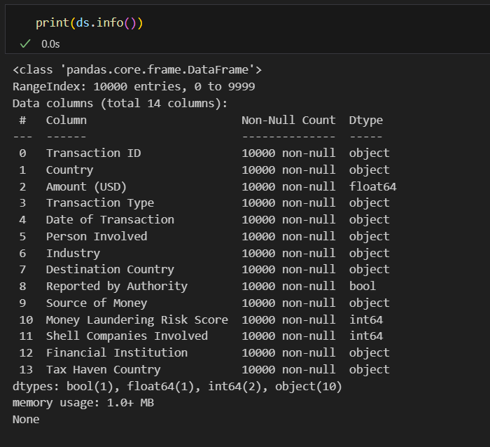

**Visualize Relationships: Using pair plots and other visualizations to explore relationships between features.**

**Use the Seaborn and Matplotlib libraries to create a pair plot. Here’s a simple explanation:**

1. **Import Libraries: The code imports Seaborn (sns) and Matplotlib’s pyplot (plt).**
2. **Create Pair Plot: The sns.pairplot(ds) function generates a grid of scatter plots for each pair of numerical features in the dataset ds. This helps in visualizing relationships between all pairs of features.**
3. **Display Plot: The plt.show() function displays the generated pair plot.**

**Pair plots are useful for identifying patterns, correlations, and potential clusters within the data, making them a valuable tool for exploratory data analysis.**

**Input:**

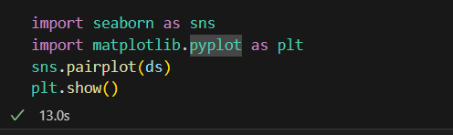

**Output:**

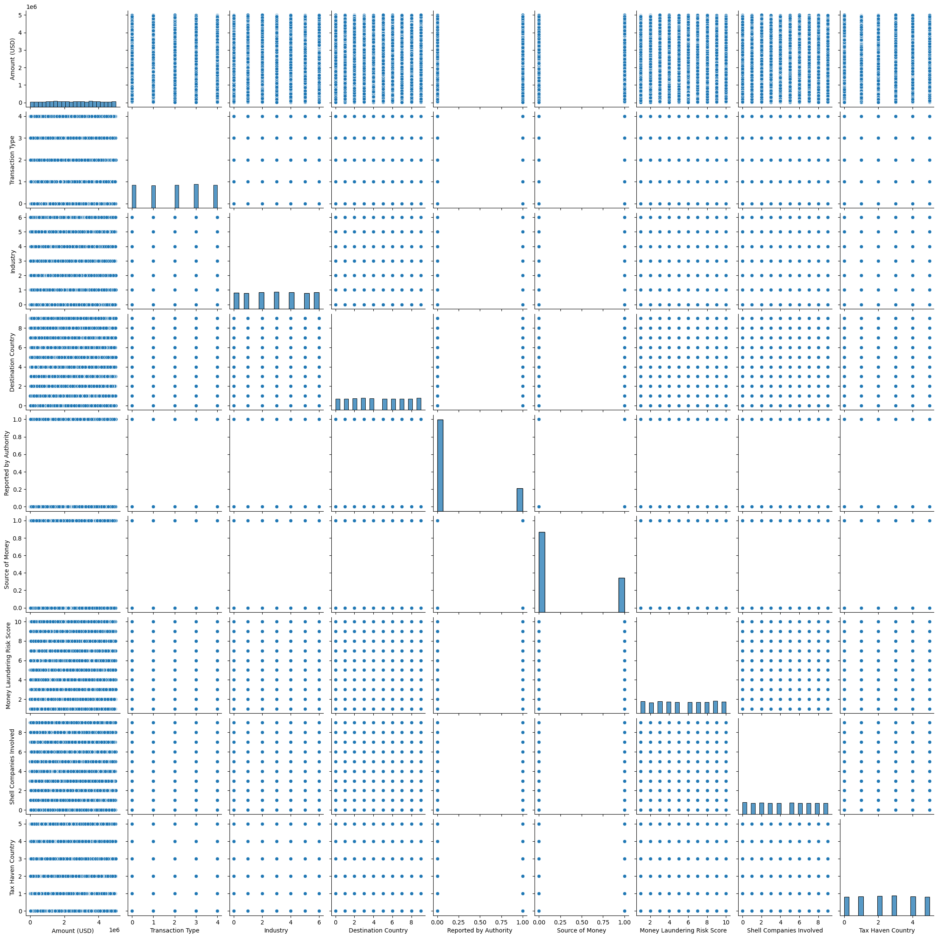

**Check for Missing Values: It’s important to ensure there are no missing values in the dataset.**

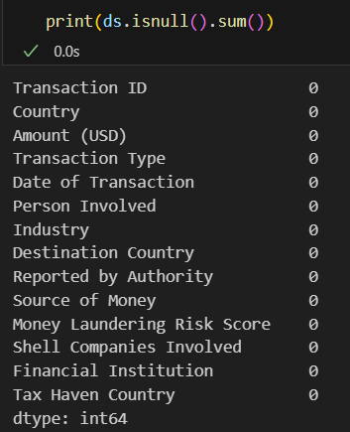

**The print(ds.isnull().sum()) command in Python, which checks for missing values in a dataset. Here’s a simple explanation:**

1. **Function Used: The isnull() function identifies missing values (NaNs) in the DataFrame ds.**
2. **Summing Missing Values: The sum() function then counts the number of missing values in each column.**
3. **Output: The output lists each column name along with the count of missing values. In this case, all columns have a count of 0, indicating there are no missing values in the dataset…….**

* **Data Preprocessing:**

**Data Preprocessing is a crucial step in preparing raw data for analysis. It involves cleaning and transforming the data to ensure its quality and suitability for modelling. Common preprocessing tasks include handling missing values, encoding categorical variables, normalizing numerical features, and detecting outliers. Effective data preprocessing enhances the accuracy and efficiency of subsequent analytical methods, leading to more reliable results.**

**Handle Missing Values:**

**Handle missing values is a critical step in data preprocessing. Common strategies include imputation, where missing values are replaced with statistical measures such as mean, median, or mode. We can fill or drop missing values depending on the context.**

* 1. **Imputation:** **This line replaces missing values in the ‘Amount (USD)’ column with the median of that column. The inplace=True argument ensures the DataFrame is modified directly.**
  2. **Dropping missing values: This line removes any rows where the ‘Transaction Type’ column has missing values. Again, inplace=True modifies the DataFrame directly.**

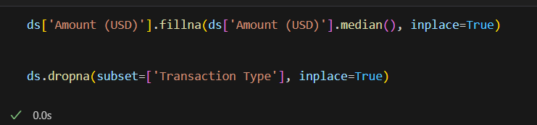

* **Identify Non-Numeric Columns :if any non-numeric values exist or not as they can cause issues when trying to compute….**

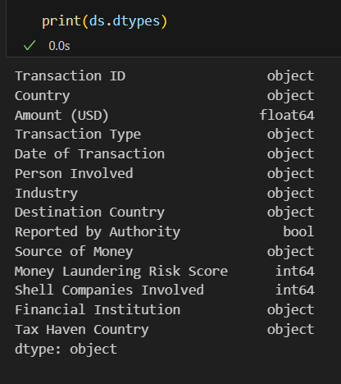

**Data Cleaning:**

**Data cleaning ensures that the dataset is free from errors and inconsistencies. This process involves removing duplicate records, correcting data entry errors, and ensuring that data is consistent across the dataset. Cleaning the data helps in improving the quality of the dataset, making it more reliable for analysis.**

**Using the IsolationForest class from the sklearn.ensemble module to detect outliers in a dataset. Here’s a simple explanation:**

1. **Import Library: The code imports IsolationForest from sklearn.ensemble.**
2. **Initialize Model: An IsolationForest model is created with a contamination parameter of 0.1, meaning it expects 10% of the data to be outliers.**
3. **Fit and Predict: The model is fitted to the numerical columns of the dataset ds, and it predicts which rows are outliers.**
4. **Filter Outliers: Rows identified as outliers (where the prediction is -1) are filtered into a new DataFrame dsi_outliers.**
5. **Display Outliers: The outliers are printed, but in this case, the resulting DataFrame is empty, indicating no outliers were detected.**

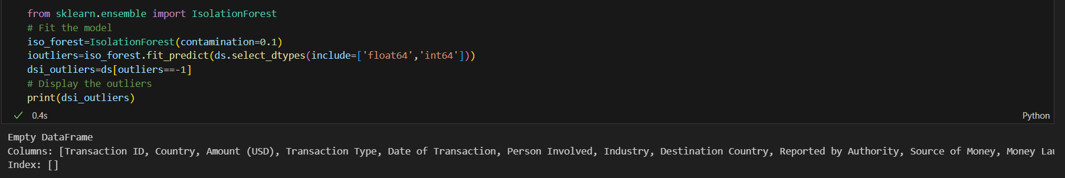

**Data Transformation:**

**Data Transformation involves converting data into a suitable format or structure for analysis. This can include normalizing or scaling numerical features to ensure they are on a similar scale, which is important for algorithms that are sensitive to the scale of data. Transformation can also involve creating new features or modifying existing ones to better capture the underlying patterns in the data.**

* **Check Column Names-using columns () function.**

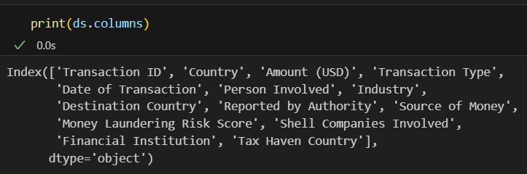

**Input:**

**Converting Categorical Columns to Codes:**

* + **ds['Transaction Type'] = ds['Transaction Type'].astype('category').cat.codes: This line converts the ‘Transaction Type’ column to a categorical data type and then assigns the category codes back to the column. This transformation changes the text values into numerical codes, which are easier for machine learning models to process.**
  + **ds['Destination Country'] = ds['Destination Country'].astype('category').cat.codes: Similarly, this line converts the ‘Destination Country’ column to a categorical data type and assigns the category codes back to the column.**

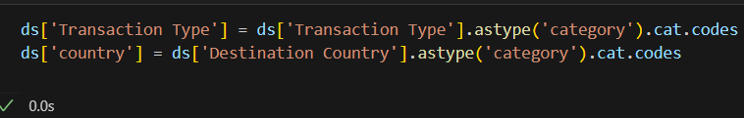

**And involves some other several data transformation steps using the pandas and sklearn libraries. Here’s a breakdown of the transformations:**

1. **Converting Data Types:**
   * **pd.to_numeric(ds['Amount (USD)'], errors='coerce'): Converts the ‘Amount (USD)’ column to numeric values, coercing any errors (e.g., non-numeric values) to NaN.**
   * **pd.to_datetime(ds['Date of Transaction'], errors='coerce'): Converts the ‘Date of Transaction’ column to datetime objects, again coercing errors to NaN.**
2. **Handling Missing Values:**
   * **The errors='coerce' parameter in the above functions ensures that any problematic data entries are converted to NaN, making it easier to handle missing values later.**
3. **Label Encoding:**
   * **LabelEncoder from sklearn.preprocessing is used to convert categorical text data into numerical values. This is done for columns like ‘Transaction Type’, ‘Tax Haven Country’, ‘Destination Country’, ‘Industry’, and ‘Source of Money’. This step is crucial for machine learning models that require numerical input.**
4. **Selecting Numeric Data:**
   * **numeric_ds = ds.select_dtypes(include=[float, int]): This line selects only the numeric columns from the dataset, which can be useful for further analysis or modeling.**

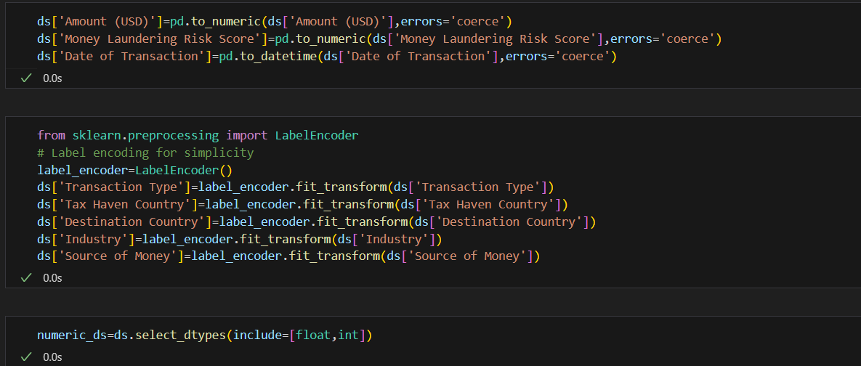

**Output of the data transformation:**

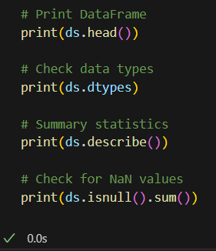

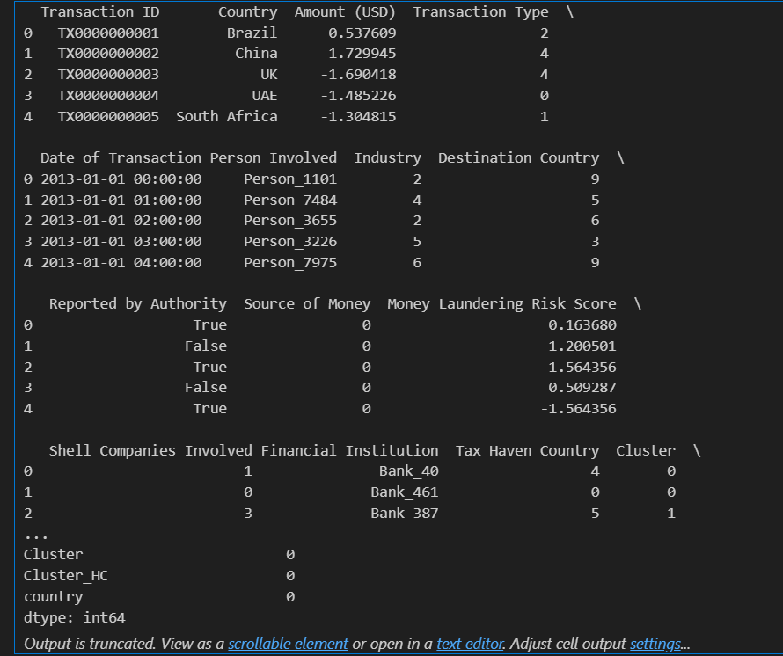

**Outlier Detection:**

**Outlier detection is the process of identifying and handling extreme values that can skew the results of an analysis. Methods such as z-scores, interquartile range (IQR), and visualizations like box plots can be used to detecr outliers. Once identified, outliers can be removed, transformed, or treated depending on the context and the impact they have on the analysis.**

1. **Z-Score Method:**

**The Z-score method calculates the standard score for each data point, which indicates how many standard deviations a data point is from the mean. Data points with a Z-score greater than a certain threshold (e.g., 3 or -3) are considered outliers.**

1. **Local Outlier Factor (LOF):**

**LOF is a density-based method that identifies outliers by comparing the local density of a point to the densities of its neighbors.**

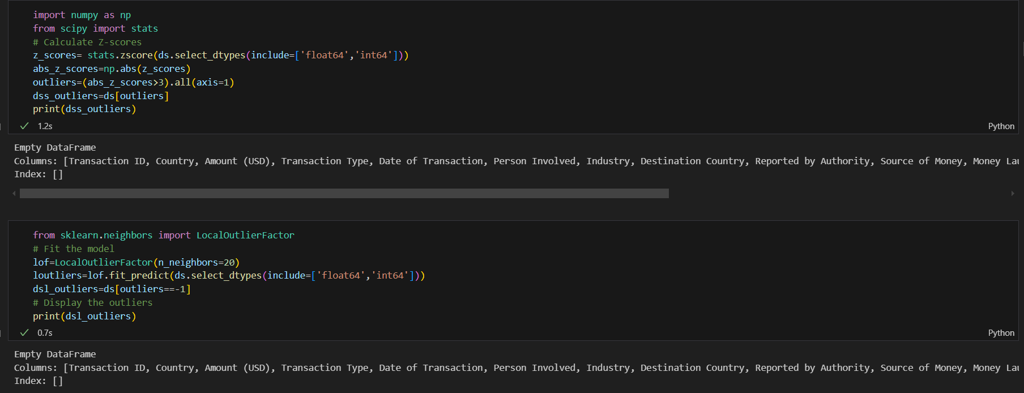

**Explanation:**

**First Block-Z-Score Method:**

1. **Import Libraries: numpy and scipy.stats.**
2. **Calculate Z-Scores: The zscore function computes the Z-scores for numerical columns in the dataset ds.**
3. **Identify Outliers: Outliers are identified as rows where the absolute Z-score is greater than 3.**
4. **Filter Outliers: These outliers are filtered into a new DataFrame dss_outliers.**
5. **Print Outliers: The outliers are printed, but the resulting DataFrame is empty, indicating no outliers were detected.**

**Second Block-Local Outlier Factor (LOF):**

1. **Import Library: LocalOutlierFactor from sklearn.neighbors.**
2. **Initialize LOF: The LOF model is initialized with 20 neighbors.**
3. **Fit and Predict: The model fits the numerical columns of the dataset ds and predicts outliers.**
4. **Filter Outliers: Rows identified as outliers (where the prediction is -1) are filtered into a new DataFrame dsl_outliers.**
5. **Print Outliers: The outliers are printed, but the resulting DataFrame is empty, indicating no outliers were detected.**

**These methods are used to identify unusual data points that may indicate anomalies or errors in the dataset.**

**Encode Categorical Variables:**

**Encoding categorical variables is essential for converting categorical data into numerical format that can be used by machine learning algorithms. Techniques such as one-hot encoding, where each category is assigned a unique integer, are commonly used. This step ensures that categorical data is appropriately represented in the analysis.**

1. **Import Libraries:** 
   * **This imports the StandardScaler class from the sklearn.preprocessing module, which is used for feature scaling.**
2. **Select Features:** 
   * **This line specifies the features to be scaled.**
3. **Initialize Scaler:**
   * **This creates an instance of StandardScaler.**
4. **Fit and Transform:**
   * **This scales the specified features in the dataset ds by fitting the scaler to the data and then transforming it.**
5. **One-Hot Encoding:**
   * **This converts categorical variables into numerical format using one-hot encoding, dropping the first category to avoid the dummy variable trap.**
6. **Print Results:**
   * **These lines print the scaled features and the entire dataset with one-hot encoded categorical variables.**

**Output Explanation:**

1. **Scaled Features:**
   * **The first print statement shows the ‘Amount (USD)’ and ‘Money Laundering Risk Score’ columns after scaling. The values are transformed to have a mean of 0 and a standard deviation of 1.**
2. **Encoded Dataset:**
   * **The second print statement shows the entire dataset with categorical variables converted into numerical format through one-hot encoding. This means each category is represented as a separate binary column (0 or 1), except for the first category which is dropped.**

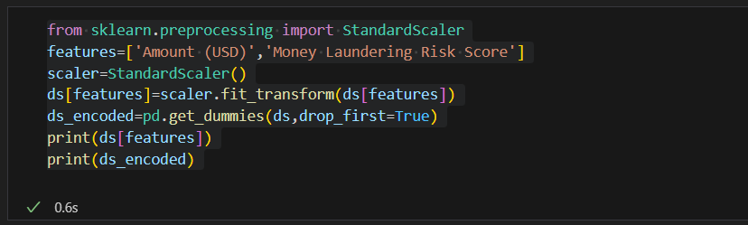

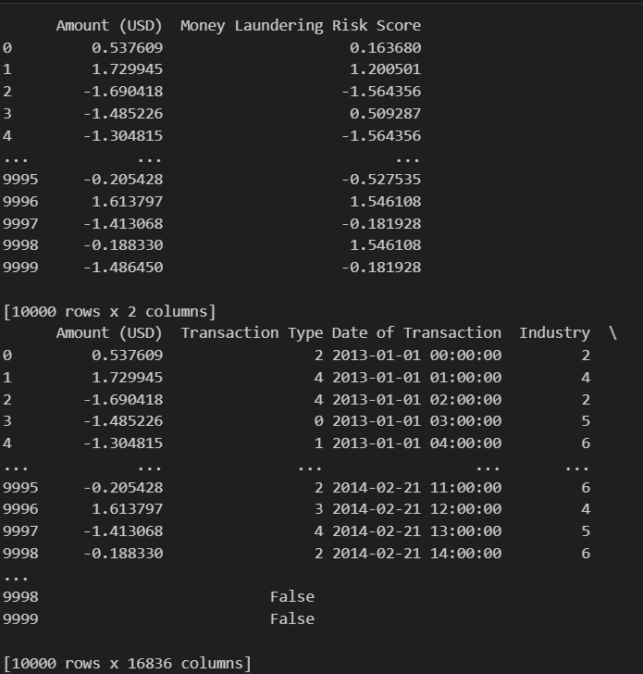

**Standardize the Features:**

**Standardizing the features involves scaling data to have a mean of zero and a standard deviation of one. This is particularly important for algorithms that rely on distance metrics, such as k-means clustering or principal component analysis (PCA). Standardization ensures that all features contribute equally to the analysis and helps in improving the performance of the models.**

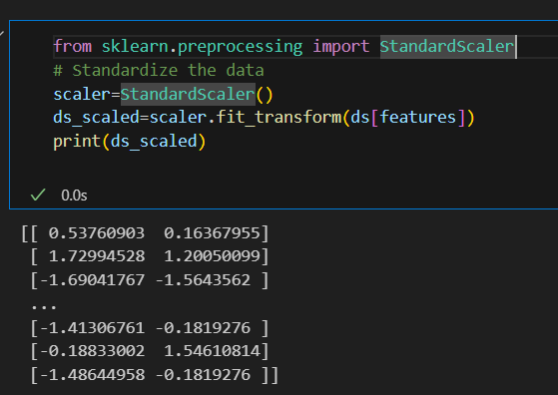

**standardizing data using the StandardScaler from the sklearn.preprocessing module. Here’s a simple explanation:**

**Code Explanation:**

1. **Import Library:**
   * **This imports the StandardScaler class, which is used for feature scaling.**
2. **Initialize Scaler:**
   * **This creates an instance of StandardScaler.**
3. **Fit and Transform:**
   * **This scales the specified features in the dataset ds by fitting the scaler to the data and then transforming it. The result is stored in ds_scaled.**
4. **Print Scaled Data:**
   * **This prints the scaled data. The output shows a 2D array where each feature has been standardized to have a mean of 0 and a standard deviation of 1.**

**Output Explanation:**

**The output is a 2D array of scaled feature values. Each row represents a data point, and each column represents a scaled feature. The values are transformed such that they have a mean of 0 and a standard deviation of 1, which helps in normalizing the dataset for better performance in machine learning models. For example:**

* **[ 0.53760903, 0.16367955] indicates the first data point after scaling.**
* **[ 1.72994528, 1.20050099] indicates the second data point after scaling.**
* **[-1.69041767, -1.5643562 ] indicates the third data point after scaling.**
* **Exploratory Data Analysis:**

**Exploratory Data Analysis (EDA) is a crucial step in the data analysis process, aimed at understanding the underlying structure of the data, identifying patterns, detecting anomalies, and checking assumptions. EDA uses various techniques to summarize the main characteristics of the data, often with visual methods.**

**Key Objectives of EDA:**

1. **Understand Data Structure: Identify patterns, relationships, and anomalies in the data.**
2. **Detect Outliers: Find unusual data points that may indicate errors or significant variations.**
3. **Generate Hypotheses: Formulate hypotheses based on observed data patterns.**
4. **Check Assumptions: Validate assumptions required for statistical modeling.**

**Common Techniques:**

1. **Univariate Analysis: Examines each variable individually using summary statistics (mean, median, mode) and visualizations (histograms, box plots).**
2. **Bivariate Analysis: Analyzes relationships between two variables using scatter plots, correlation matrices, and cross-tabulations.**
3. **Multivariate Analysis: Investigates interactions between multiple variables using techniques like pair plots and dimensionality reduction (PCA).**

**Tools and Methods:**

* **Statistical Functions: Mean, median, standard deviation, etc.**
* **Visualization Tools: Histograms, box plots, scatter plots, heatmaps.**
* **Clustering and Dimension Reduction: Techniques like K-means clustering and PCA to visualize high-dimensional data.**

1. **Univariate Analysis:**

**Univariate analysis involves examining a single variable. IT focuses on summarizing and finding patterns within that variable. There are two main types:**

* **Non-Graphical: This includes statistical measures such as mean, median, mode, variance and standard deviation. These metrics help describe the central tendency and dispersion of the data.**

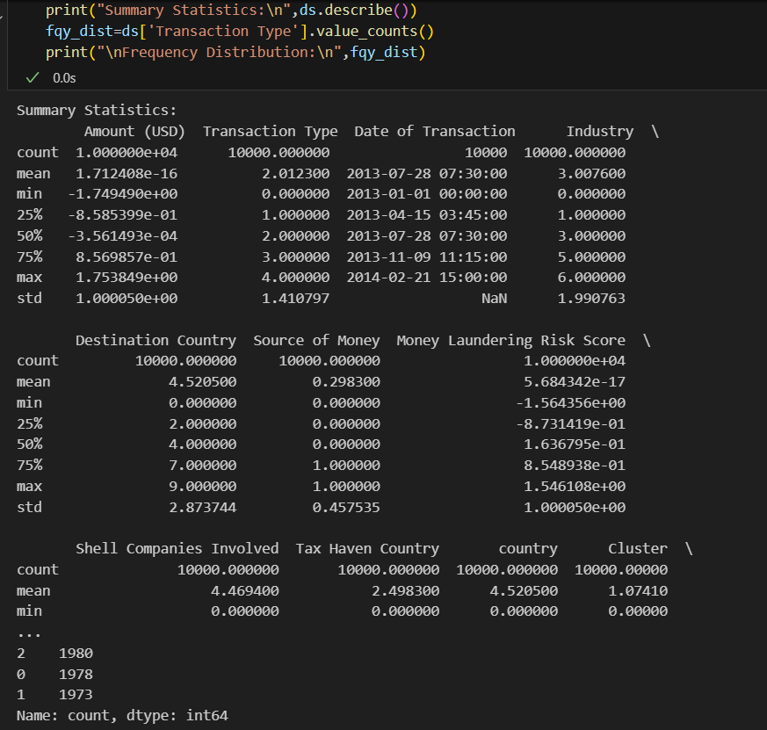

* **Graphical: Visual methods like histograms, countplots and other plots are used to visualize the distribution and identify outliers.**

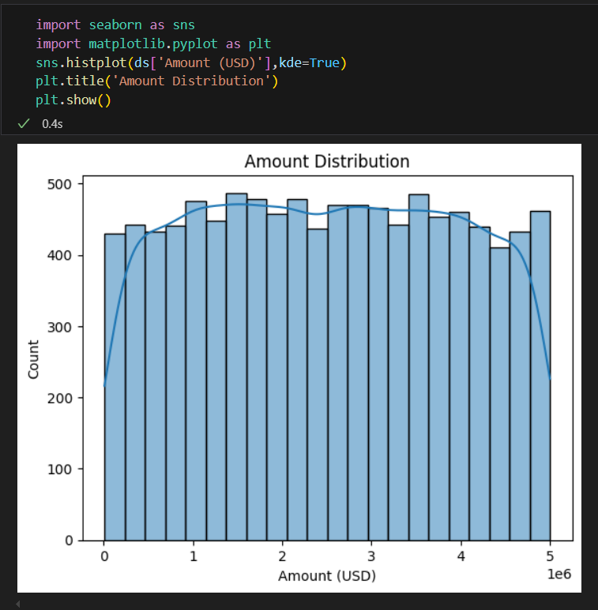

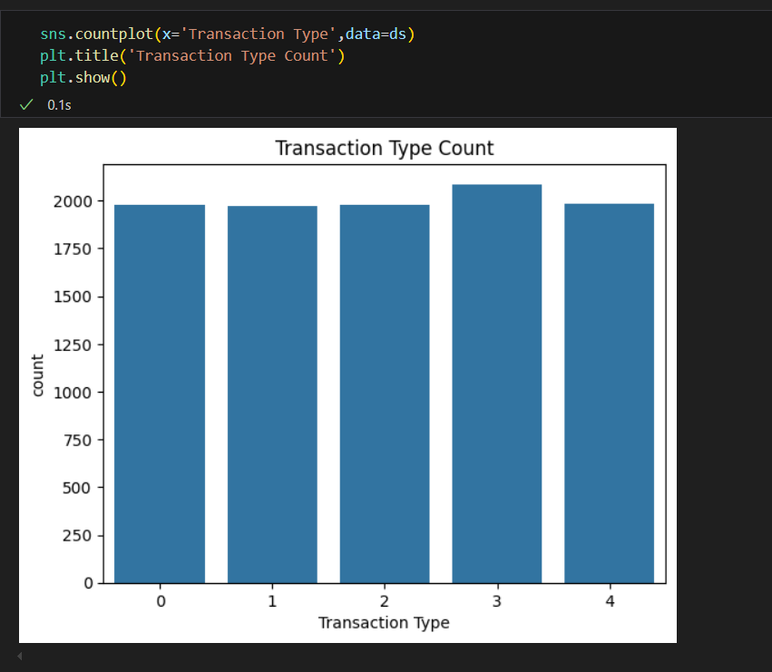

1. **Bivariate Analysis:**

**Bivariate analysis explores the relationship between two variables. It helps in understanding how one variable affects another.**

* **Non-Graphical: Correlation coefficients and cross tabulations are used to quantify the relationship between variables.**

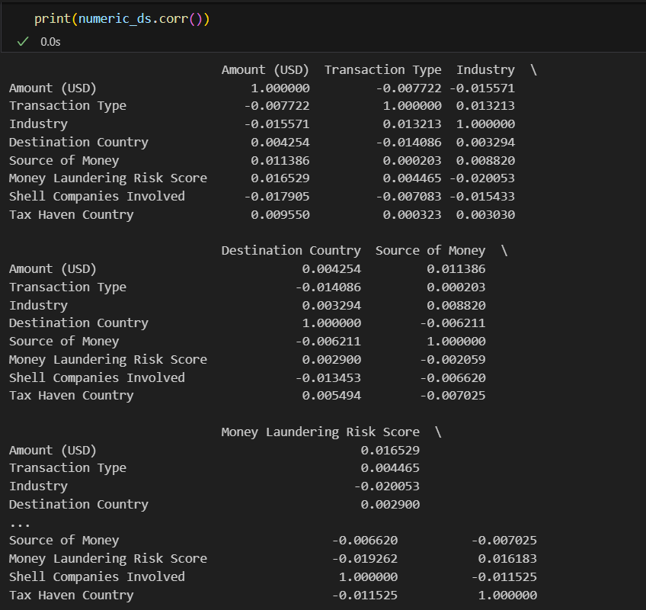

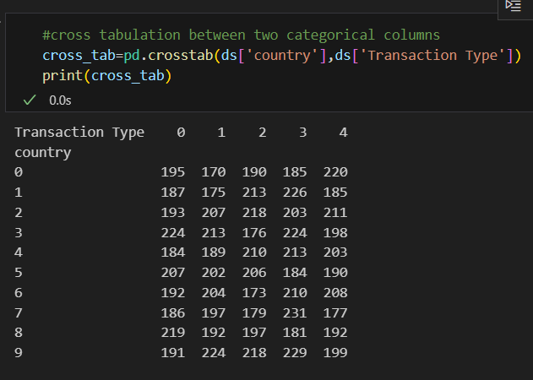

* **Graphical: Scatter plots, box plots and line graphs are used to visualize the relationship and identify trends or patterns.**

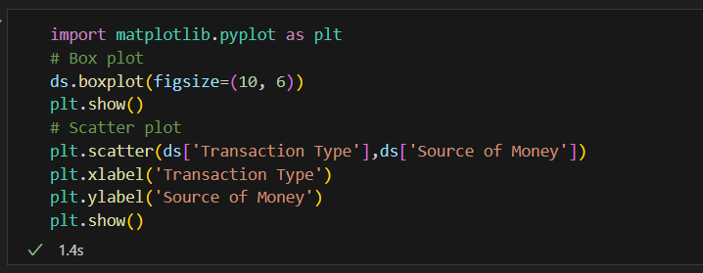

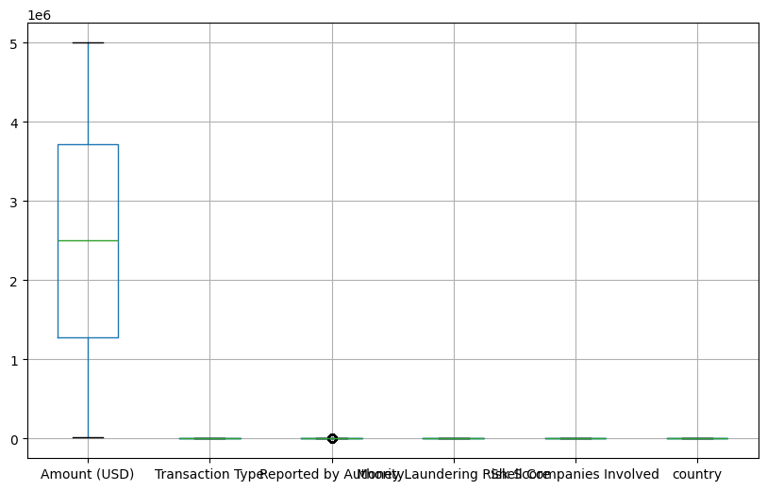

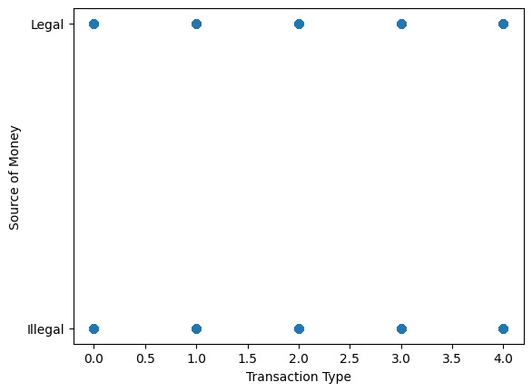

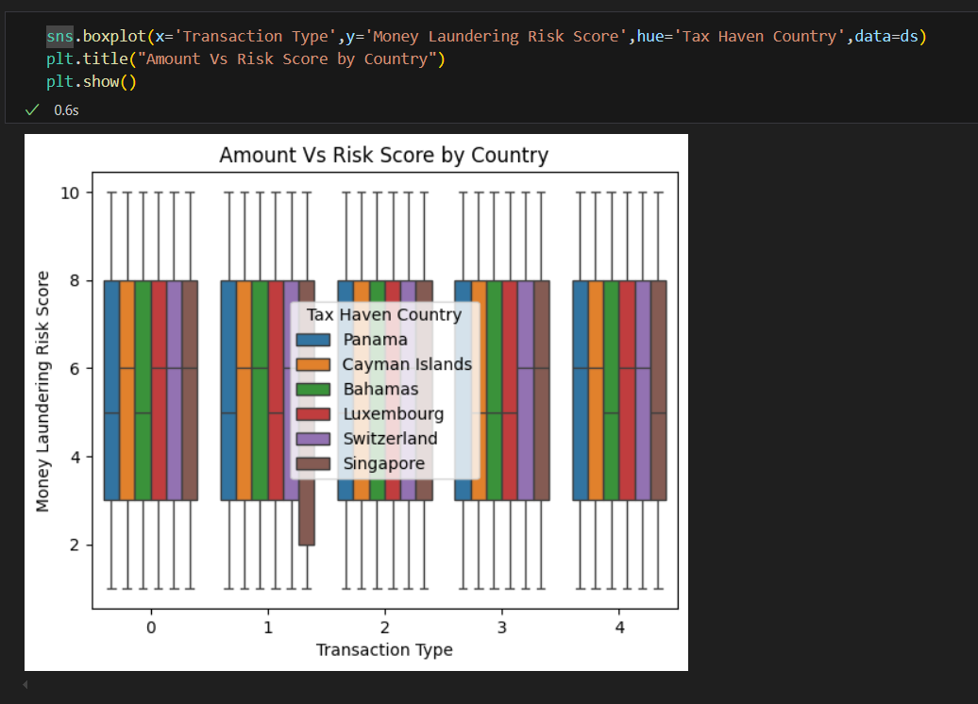

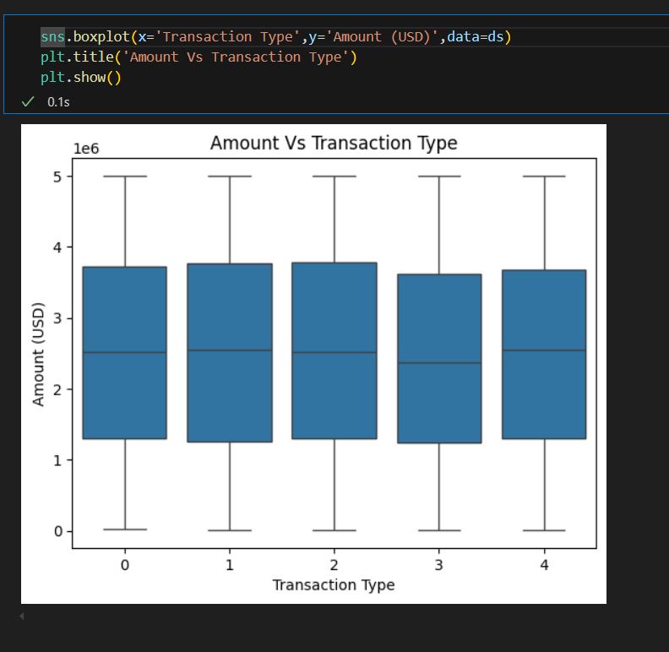

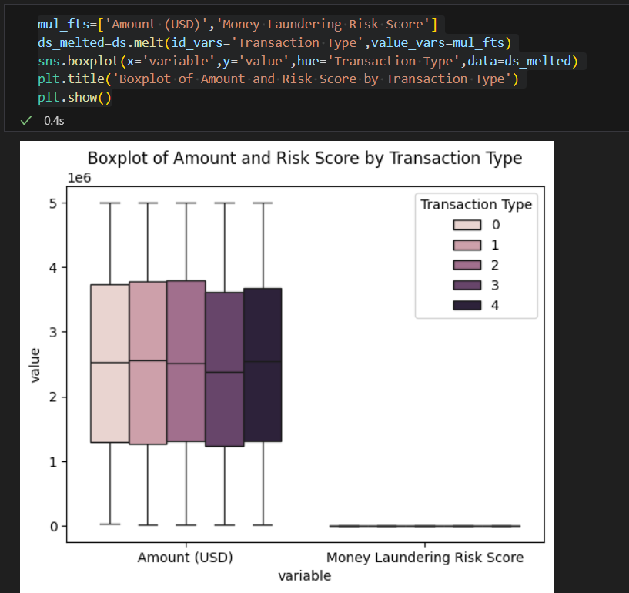

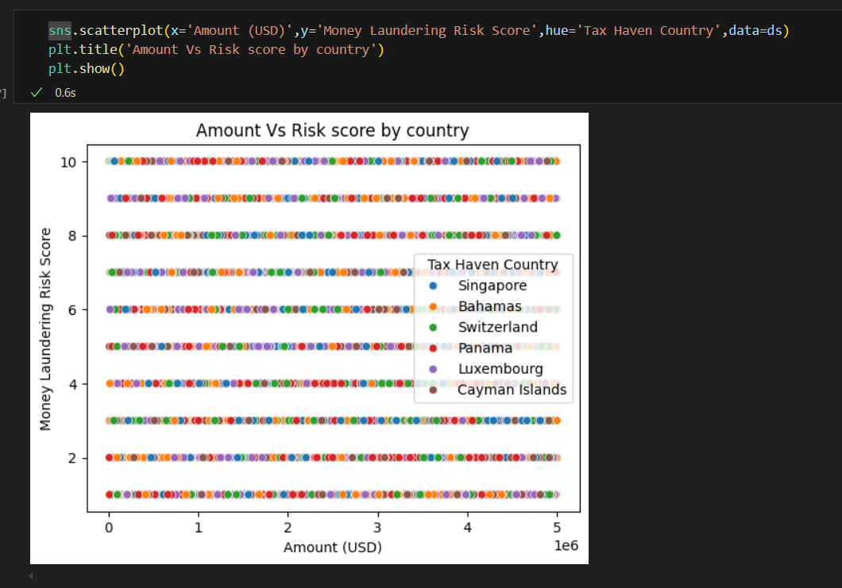

**Pearson Correlation:**

**Purpose: Measures the linear relationship between two continuous variables.**

**Range: Values range from -1 to 1, where 1 indicates a perfect positive linear relationship, -1 indicates a perfect negative linear relationship and 0 indicates no linear relationship.**

**Assumptions: Assumes that the data is normally distributed and the relationship between variables is linear.**

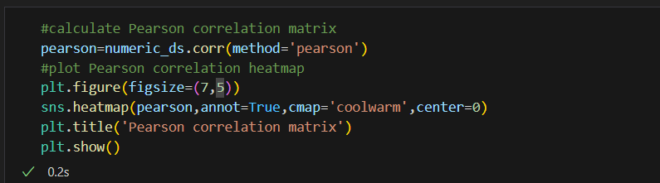

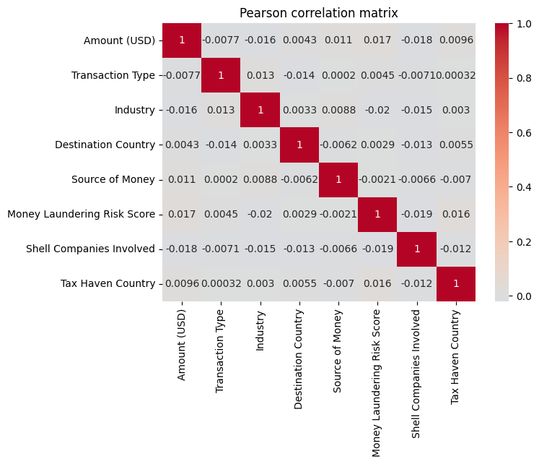

**Spearman Correlation:**

**Purpose: Measures the monotonic relationship between two continuous or ordinal variables.**

**Range: Values range from -1 to 1, similar to Pearson correlation.**

**Assumptions: Does not assume a linear relationship or normally distributed data. It is based on the ranks of the data rather than the raw data values.**

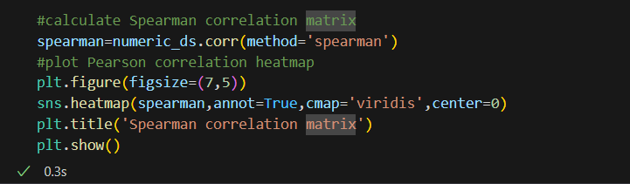

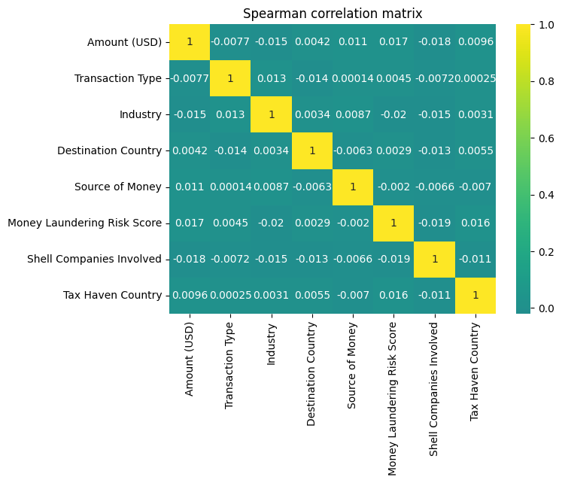

1. **Multivariate Analysis:**

**Multivariate analysis examines more than two variables simultaneously to understand the relationships and interactions between them. This type of analysis is more complex and includes:**

* **Non-Graphical: Techniques like cross-tabulations and summary statistics for multiple variables.**
* **Graphical: Methods such as pair plots, heatmaps , and 3D scatter plots are used to visualize interactions between multiple variables.**

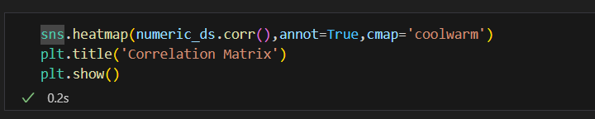

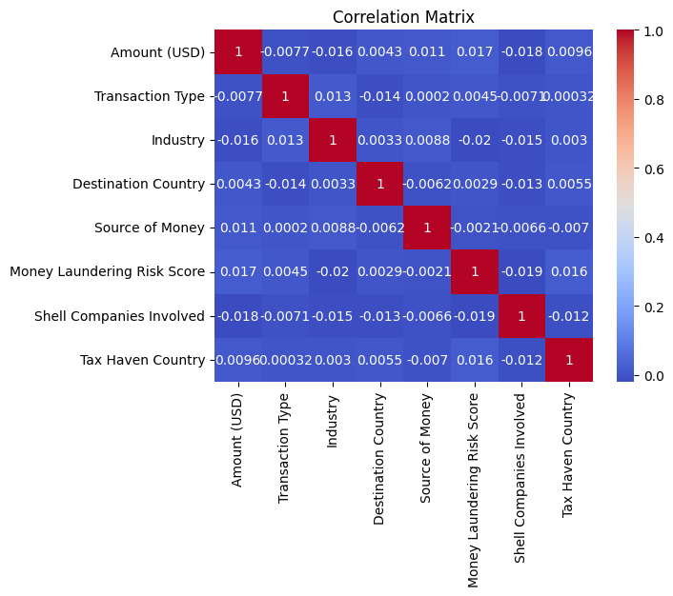

**Importance of EDA:**

**EDA is essential because it helps in:**

* **Identifying patterns: Detecting trends and patterns that might not be obvious.**
* **Detecting Anomalies: Finding outliers and anomalies that could affect the analysis.**
* **Formulating Hypotheses: Generating hypotheses for further analysis and testing.**
* **Guiding Data Cleaning: Identifying issues such as missing values and inconsistencies that need to be addressed.**

**By using EDA, analysts can gain a deeper understanding of the data, which is crucial for making informed decisions and building robust models.**

* **Dimensionality Reduction:**

**Reduce the dataset size while retaining important information. Use techniques like Principal Component Analysis (PCA) or t-Distributed Stochastic Neighbour Embedding(t-SNE) to reduce the number of features.**

**1.Principal Component Analysis (PCA): PCA is a linear dimensionality reduction technique that transforms high-dimensional data into a lower-dimensional form while preserving as much variance as possible. PCA achieves this by identifying the principal components, which are linear combinations of the original variables that capture the maximum variance. This method is widely used for visualizing complex datasets, reducing noise, and improving the efficiency of machine learning algorithms.**

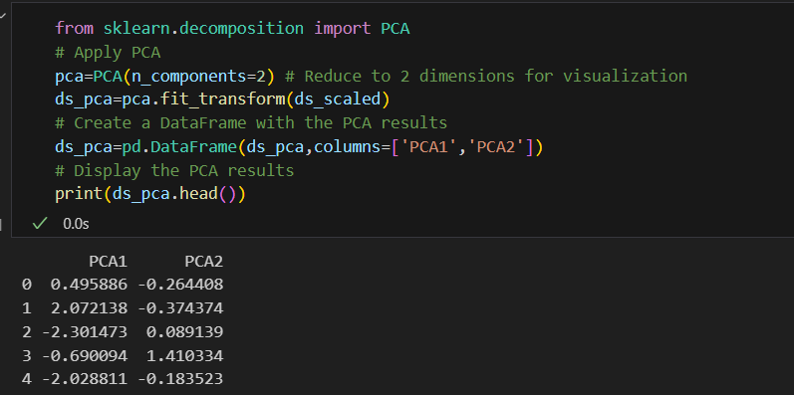

**2.T-Distributed Stochastic Neighbor Embedding(t-SNE):** **t-Distributed Stochastic Neighbor Embedding (t-SNE) is a non-linear dimensionality reduction technique particularly well-suited for visualizing high-dimensional data. Unlike PCA, t-SNE focuses on preserving the local structure of the data, making it effective for revealing clusters and patterns that may not be apparent in the original high-dimensional space. t-SNE is commonly used in exploratory data analysis to gain insights into the underlying structure of complex datasets.**

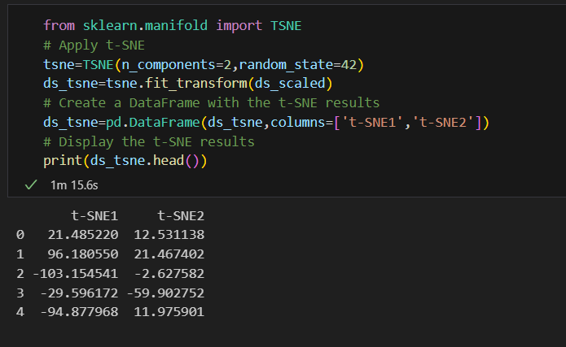

**Output of PCA and t-SNE:**

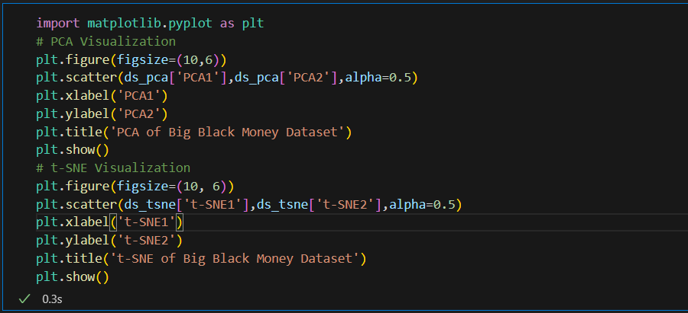

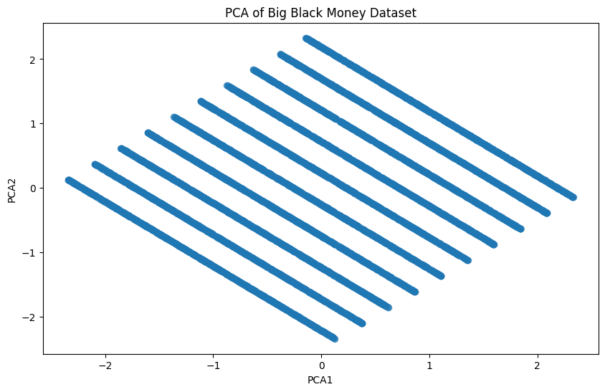

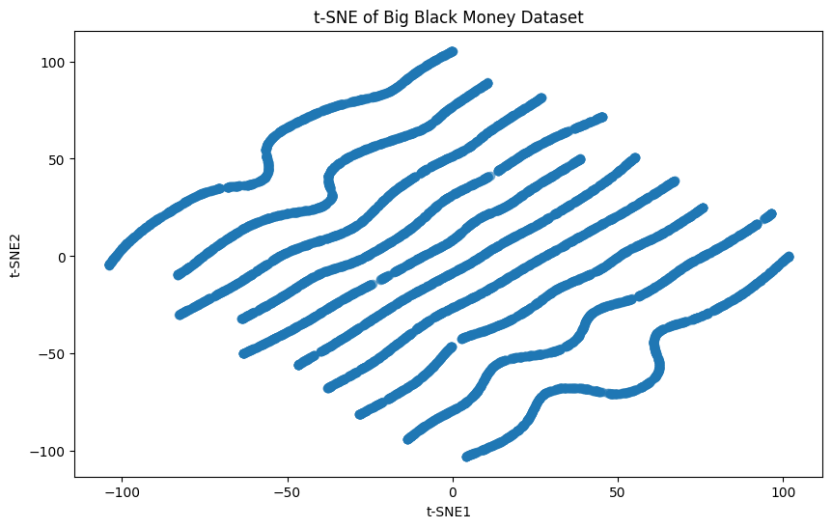

* **Cluster Analysis:**
* **Cluster analysis is a technique used to group similar data points into clusters based on their characteristics.**
* **The goal is to ensure that data points within the same cluster are more similar to each other than to those in other clusters.**
* **Common clustering algorithms include K-Means, Hierarchical Clustering, and DBSCAN.**

* **Cluster analysis is widely used in various fields, such as market segmentation to anomaly detection, image analysis, and bioinformatics, to identify natural groupings in data.**

**1.K-Means Clustering:**

* **K-Means Clustering aims to group similar data points together into clusters.**
* **The number of clusters-K is specified by the user.**
* **The algorithm works by minimizing the variance within each cluster, ensuring that data points within the same cluster are as similar as possible while those in different clusters are as distinct as possible.**

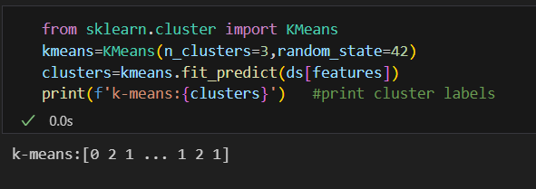

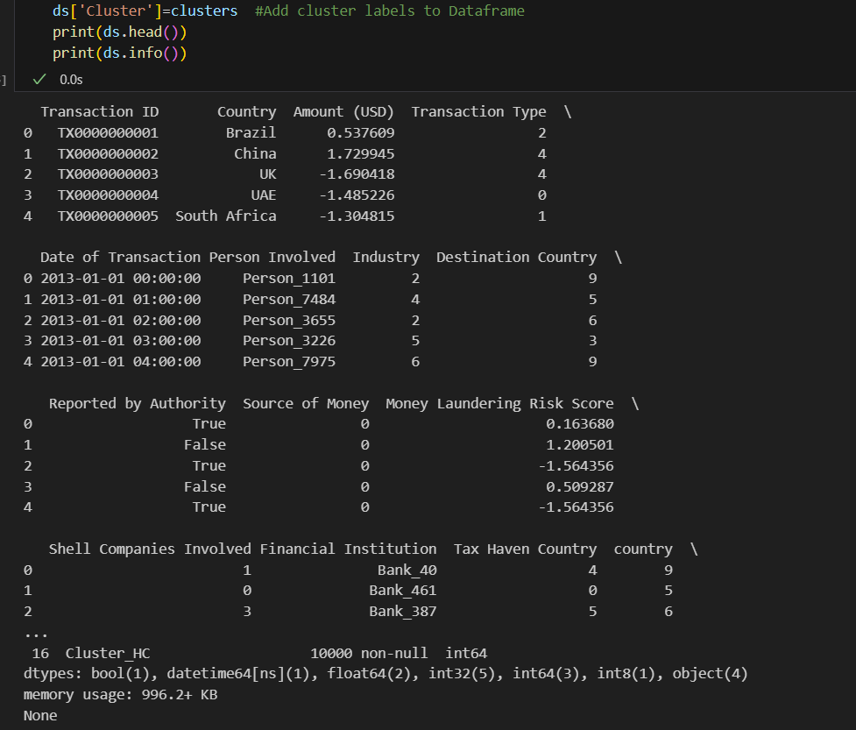

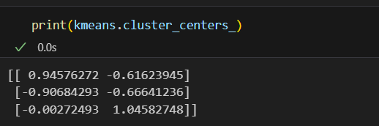

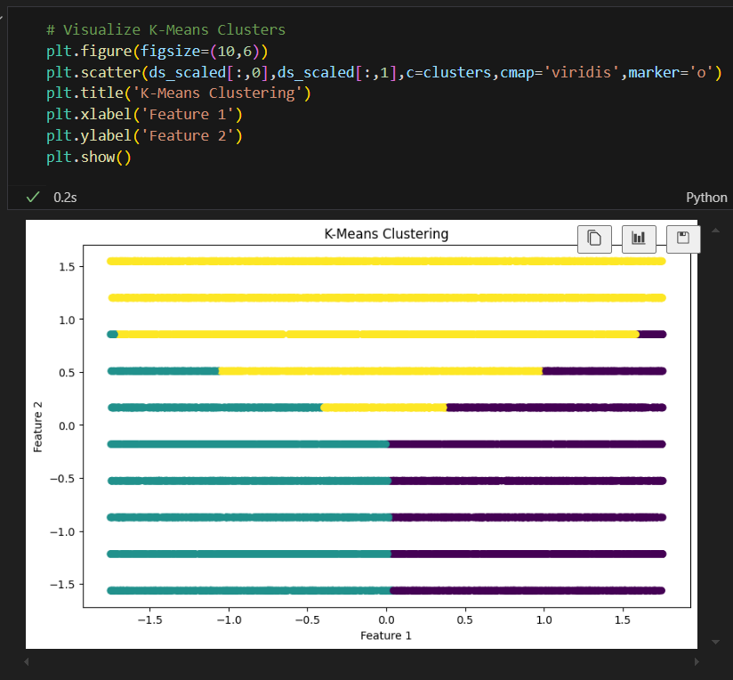

**2.Hierarchical Clustering:**

**Hierarchical clustering is a method of cluster analysis which seeks to build a hierarchy of clusters. It is an unsupervised learning technique used to group similar data points into clusters based on their similarity.**

**Steps Involved:**

1. Creating a Dendrogram:

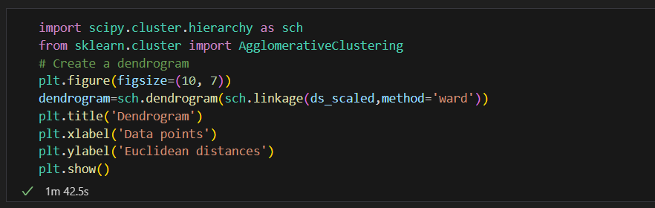

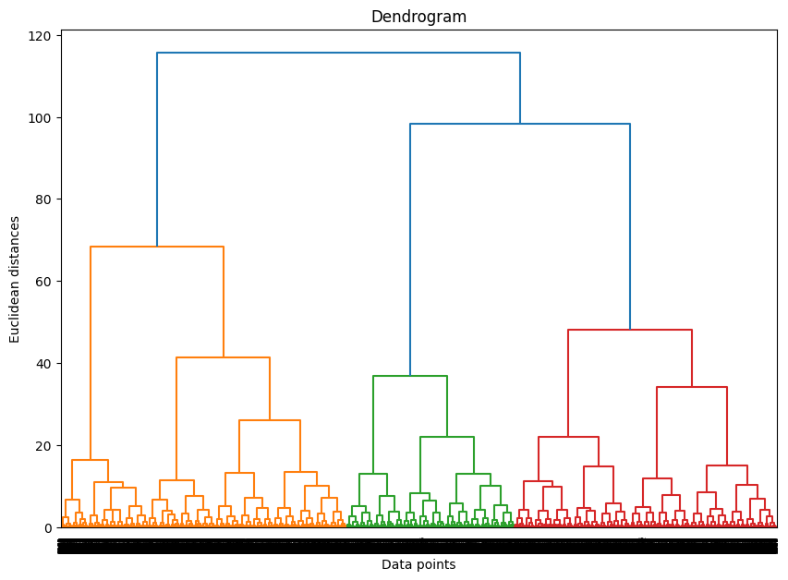

* **Dendrogram: A tree-like diagram that records the sequences of merges or splits. It helps in determining the optimal number of clusters by visualizing the distances at which clusters are merged.**
* **Ward’s Method: This method minimizes the variance within each cluster, making it a popular choice for hierarchical clustering.**

1. **Applying Agglomerative clustering:**

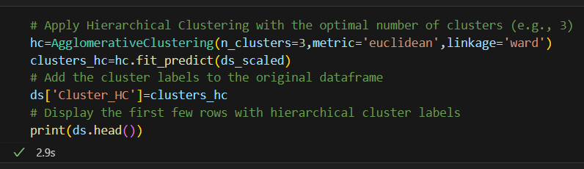

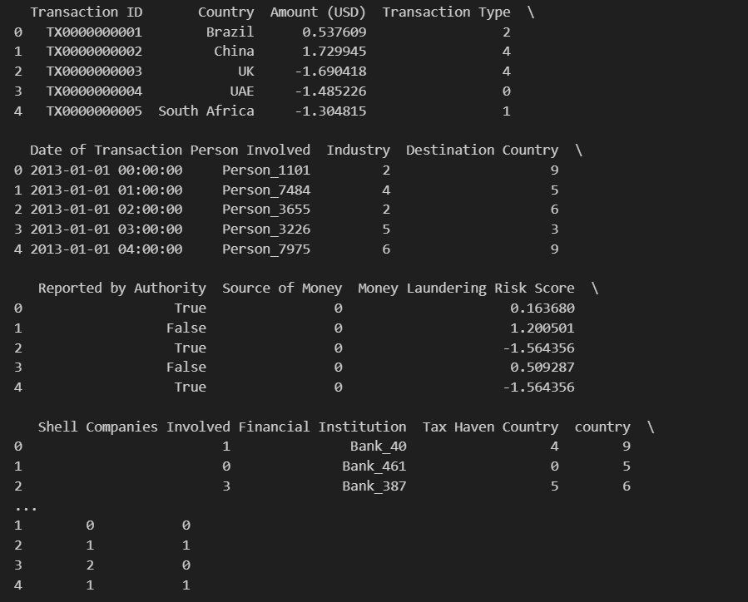

* **Agglomerative Clustering: A bottom-up approach where each data point starts in its own cluster, and pairs of clusters are merged as one moves up the hierarchy.**
* **Cluster Labels: The fit_predict method assigns each data point to a cluster, and these labels are added to the original DataFrame for further analysis.**

1. **Visualizing Hierarchical Clusters:**

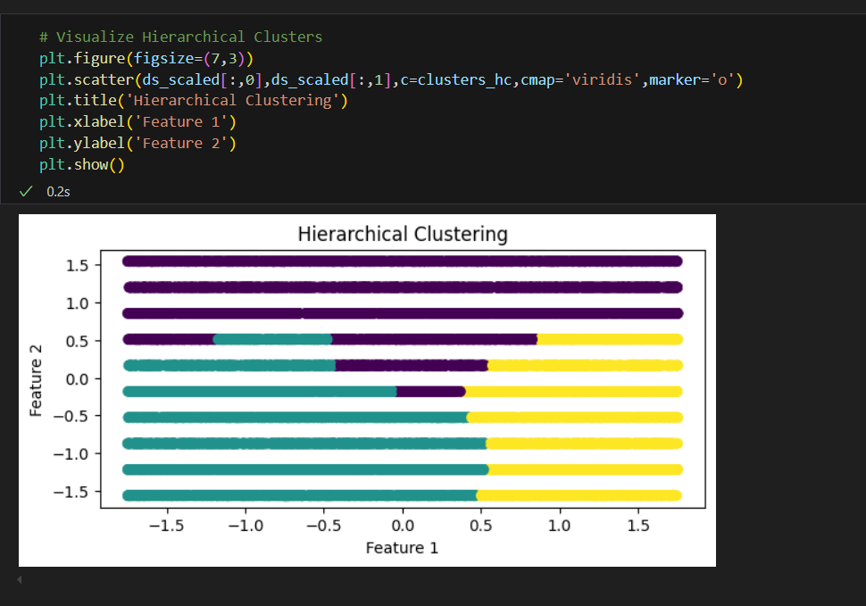

* **Evaluation and Interpret-Elbow Method & Silhouette Score:**

**Elbow Method:**

**The Elbow Method is a technique used to determine the optimal number of clusters in a dataset for k-means clustering. It involves plotting the within-cluster sum of squares (WCSS) against the number of clusters. The “elbow” point on the plot indicates the optimal number of clusters, where adding more clusters does not significantly improve the model.**

**Implementing the Elbow Method using the KMeans algorithm from the scikit-learn library. Here’s a step-by-step explanation:**

1. **Import Libraries:**
   * **This imports the necessary libraries for clustering and plotting.**
2. **Initialize WCSS List:**
   * **This creates an empty list to store the within-cluster sum of squares for each number of clusters.**
3. **Fit KMeans for Different Cluster Numbers:**
   * **This loop runs the KMeans algorithm for cluster numbers ranging from 1 to 10.**
   * **kmeans.inertia_ stores the WCSS for each clustering.**
4. **Plot the Elbow Graph:**
   * **This code plots the WCSS against the number of clusters.**
   * **The plot helps identify the “elbow” point, indicating the optimal number of clusters.**

**Output Explanation:**

**The plot generated by this code will show the WCSS on the y-axis and the number of clusters on the x-axis.**

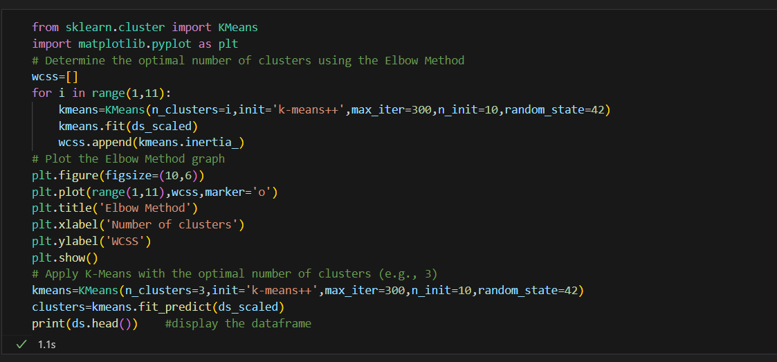

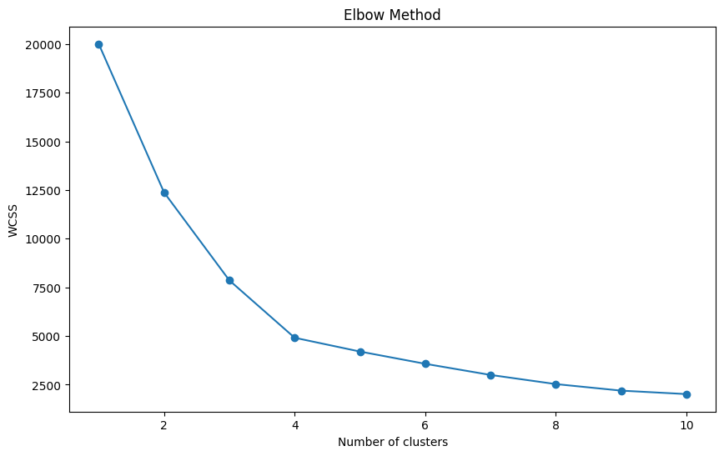

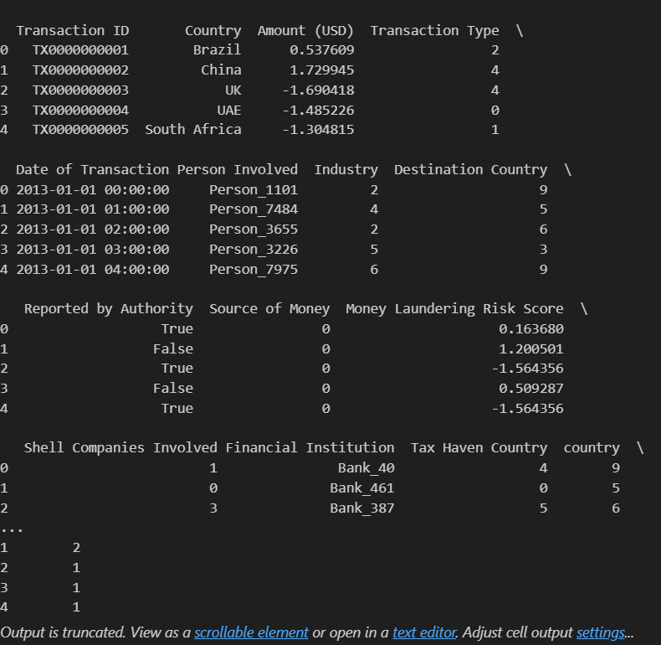

**Silhouette Score:**

**The silhouette score is a metric used to evaluate the quality of clusters in a dataset. It measures how similar an object is to its own cluster (cohesion) compared to other clusters (separation). The score ranges from -1 to 1:**

* **1: Indicates that the object is well matched to its own cluster and poorly matched to neighboring clusters.**
* **0: Indicates that the object is on or very close to the decision boundary between two neighboring clusters.**
* **-1: Indicates that the object might have been assigned to the wrong cluster.**

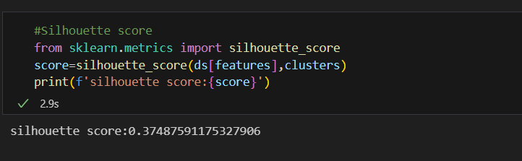

**Code Explanation:**

**The image shows a Python code snippet that calculates the silhouette score for a clustering result. Here’s a step-by-step explanation:**

1. **Import Library:**
   * **This imports the silhouette_score function from the sklearn.metrics module.**
2. **Calculate Silhouette Score:**
   * **This calculates the silhouette score for the data points in ds[features] clustered into clusters.**
3. **Print the Score:**
   * **This prints the calculated silhouette score.**

**Output Explanation:**

**The output shows the silhouette score:**

**silhouette score: 0.37487591175327906**

* **A score of approximately 0.375 suggests moderate cohesion and separation among the clusters. This means the clusters are reasonably well-defined but could potentially be improved.**
* **Decision Tree**
* **Introduction of Decision Tree:**

**Formally a decision tree is a graphical representation of all possible solutions to a decision. These days, tree-based algorithms are the most commonly used algorithms in the case of supervised learning scenarios. They are easier to interpret and visualize with great adaptability. We can use tree-based algorithms for both regression and classification problems, However, most of the time they are used for classification problem.**

* **Terminologies associated with Decision Tree:**

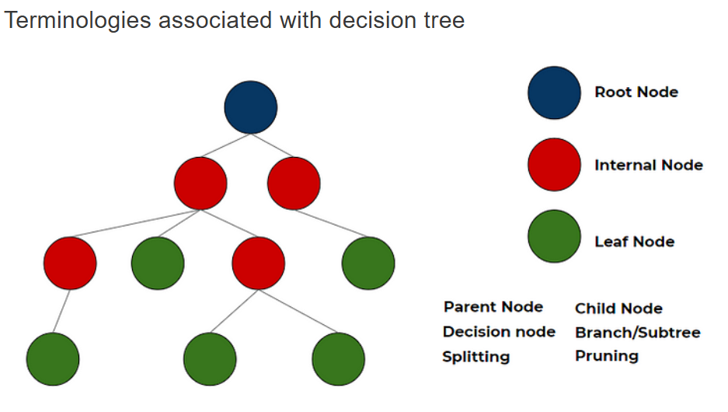

* **Parent Node: In any two connected nodes, the one which is higher hierarchically, is a parent node.**
* **Child Node: In any two connected nodes, the one which is lower hierarchically, is a child node.**
* **Root Node: The starting node from which the tree starts, It has only child nodes. The root node does not have a parent node.**
* **Leaf Node/Leaf: Nodes at the end of the tree, which do not have any children are leaf nodes or called simply leaf.**
* **Internal nodes/nodes: All the in-between the root node and the leaf nodes are internal nodes or simply called nodes. Internal nodes have both a parent and at least one child.**
* **Splitting: Dividing a node into two or more sub-nodes or adding two or more children to a node.**
* **Decision Node: When a parent splits into two or more children nodes then that node is called a decision node.**
* **Pruning: When we remove the sub-node of a decision node, it is called pruning and taken as the opposite process of splitting.**
* **Branch/Sub-tree: A subsection of the entire tree is called a branch or sub-tree.**
* **Types of Decision Tree:**
* **Regression Tree:**

**A regression tree is used when the dependent variable is continuous. The value obtained by leaf nodes in the training data is the mean response of observation falling in that region. Thus, if an unseen data observation falls in that region, its prediction is made with the mean value. This means that even if the dependent variable in training data was continuous, it will only take discrete values in the test set. A regression tree follows a top-down greedy approach.**

* **Classification Tree:**

**A classification tree is used when the dependent variable is categorical. The value obtained by leaf nodes in the training data is the mode response of observation falling in that region It follows a top-down greedy approach.**

**Together they are called as CART (classification and regression tree).**

* **Building a Decision Tree from data:**

**The decision of making strategic splits heavily affects a tree’s accuracy. The purity of the node should increase with respect to the target variable after each split. The decision tree splits the nodes on all available variables and then selects the split which results in the most homogeneous sub-nodes.**

**The following are the most commonly used algorithms for splitting.**

1. **Gini Impurity:**

**Gini says, if we select two items from a population at random then they must be of the same class and the probability for this is 1 if the population is pure.**

* **It works with the categorical target variable “Success” or “Failure”.**
* **It performs only Binary splits.**
* **Higher the value of Gini higher the homogeneity.**
* **CART (Classification and Regression Tree) uses the Gini method to create binary splits.**

**Steps to Calculate Gini impurity for a split:**

1. **Calculate Gini impurity for sub-nodes, using the formula subtracting the sum of the square of probability for success and failure from one.  
   1-(p²+q²)  
   where p =P(Success) & q=P(Failure)**
2. **Calculate Gini for split using the weighted Gini score of each node of that split.**
3. **Select the feature with the least Gini impurity for the split.**
4. **Chi-Square:**

**It is an algorithm to find out the statistical significance between the differences between sub-nodes and parent node. We measure it by the sum of squares of standardized differences between observed and expected frequencies of the target variable.**

* **It works with the categorical target variable “Success” or “Failure”.**
* **It can perform two or more splits.**
* **Higher the value of Chi-Square higher the statistical significance of differences between sub-node and Parent node.**
* **Chi-Square of each node is calculated using the formula,**
* **Chi-square = ((Actual — Expected)² / Expected)¹/2**
* **It generates a tree called CHAID (Chi-square Automatic Interaction Detector).**

**Steps to Calculate Chi-square for a split:**

1. **Calculate Chi-square for an individual node by calculating the deviation for Success and Failure both.**
2. **Calculated Chi-square of Split using Sum of all Chi-square of success and Failure of each node of the split.**
3. **Select the split where Chi-Square is maximum.**
4. **Information Gain:**

**A less impure node requires less information to describe it and, a more impure node requires more information. Information theory is a measure to define this degree of disorganization in a system known as Entropy. If the sample is completely homogeneous, then the entropy is zero and if the sample is equally divided (50% — 50%), it has an entropy of one. Entropy is calculated as follows.**

**Decision tree - Entropy**

**Steps to Calculate entropy for a split:**

1. **Calculate the entropy of the parent node**
2. **Calculate entropy of each individual node of split and calculate the weighted average of all sub-nodes available in the split. The lesser the entropy, the better it is.**
3. **calculate information gain as follows and chose the node with the highest information gain for splitting.**

information gain

1. **Reduction in Variance:**

**Till now, we have discussed the algorithms for the categorical target variable. Reduction in variance is an algorithm used for continuous target variables (regression problems).**

* **Used for continuous variables**
* **This algorithm uses the standard formula of variance to choose the best split.**
* **The split with lower variance is selected as the criteria to split the population.**

**Steps to Calculate Variance:**

1. **Calculate variance for each node.**  
   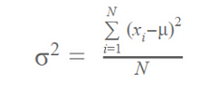
2. **Calculate variance for each split as a weighted average of each node variance.**
3. **The node with lower variance is selected as the criteria to split.**

**summary:**

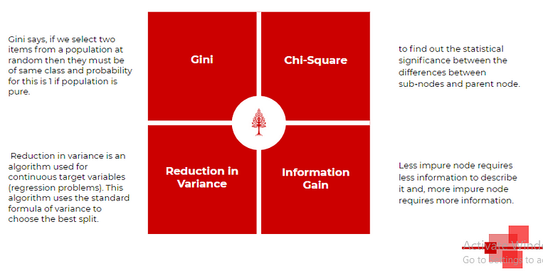

**In practice, most of the time Gini impurity is used as it gives good results for splitting and its computation is inexpensive.**

* **Avoid Overfitting in Decision Trees:**

**Overfitting is one of the key challenges in a tree-based algorithm. If no limit is set, it will give 100% fitting, because, in the worst-case scenario, it will end up making a leaf node for each observation. Hence we need to take some precautions to avoid overfitting. It is mostly done in two ways:**

1. **Setting constraints on tree size**
2. **Tree pruning.**

**Setting Constraints on tree size:**

**Parameters play an important role in tree modeling. Overfitting can be avoided by using various parameters that are used to define a tree.**

1. **Minimum samples for a node split**
   1. **Defines the minimum number of observations that are required in a node to be considered for splitting. (this ensures above mentioned worst-case scenario).**
   2. **A higher value of this parameter prevents a model from learning relations that might be highly specific to the particular sample selected for a tree.**
   3. **Too high values can lead to under-fitting hence, it should be tuned properly using cross-validation.**
2. **Minimum samples for a leaf node**
   1. **Defines the minimum observations required in a leaf. (Again this also prevents worst-case scenarios)**
   2. **Generally, lower values should be chosen for imbalanced class problems as the regions in which the minority class will be in majority will be of small size.**
3. **Maximum depth of the tree (vertical depth)**
   1. **Used to control over-fitting as higher depth will allow the model to learn relations very specific to a particular sample.**
   2. **Should be tuned properly using Cross-validation as too little height can cause underfitting.**
4. **Maximum number of leaf nodes**
   1. **The maximum number of leaf nodes or leaves in a tree.**
   2. **Can be defined in place of max_depth. Since binary trees are created, a depth of n would produce a maximum of 2^n leaves.**
5. **Maximum features to consider for a split**
   1. **The number of features to consider while searching for the best split. These will be randomly selected.**
   2. **As a thumb-rule, the square root of the total number of features works great but we should check up to 30–40% of the total number of features.**
   3. **Higher values can lead to over-fitting but depend on case to case.**

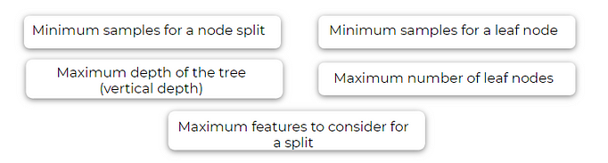**Pruning:Pruning is something opposite to splitting.**

* **Advantages and Disadvantages of Decision Tree:**
* **Advantages:**
* **Easy to visualize and interpret: Its graphical representation is very intuitive to understand and it does not require any knowledge of statistics to interpret it.**
* **Useful in data exploration: We can easily identify the most significant variable and the relation between variables with a decision tree. It can help us create new variables or put some features in one bucket.**
* **Less data cleaning required: It is fairly immune to outliers and missing data, hence less data cleaning is needed.**
* **The data type is not a constraint: It can handle both categorical and numerical data.**
* **Disadvantages:**
* **Overfitting: Single Decision tree tends to overfit the data which is solved by setting constraints on model parameters i.e. height of the tree and pruning.**
* **Not exact fit for continuous data: It losses some of the information associated with numerical variables when it classifies them into different categories.**
* **Implementing a Decision Tree using Python:**

**In this section, we will see how to implement a decision tree using python… We will continue from the above techniques implemented on Big Black Money dataset …….**

**let’s dive deeper into the implementation and visualization of a decision tree on the Big Black Money dataset, covering Gini Impurity, Chi-Square, Information Gain, Variance Reduction, Overfitting, and Pruning.**

**Step-1: Install Required Libraries**

**Make sure that we have the necessary libraries installed.**

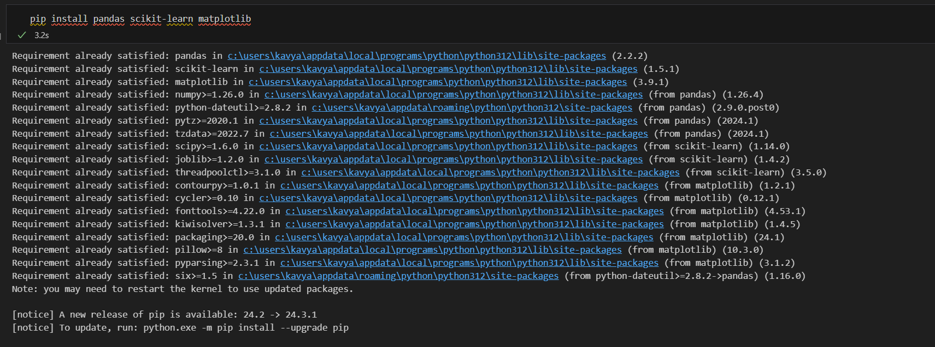

**Step-2: Load the dataset**

**In the above techniques we have loaded the dataset into a pandas dataframe…**

**Step-3: Preprocess the Data**

**Clean and preprocess the data to handle missing values, categorical variables and any necessary transforGinGmations as in the above techniques.**

**Step-4: Split the Data**

**Split the dataset into training and test sets.**

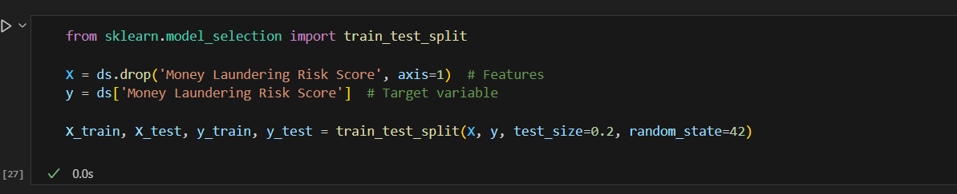

**Step-5:Train the Decision Tree Model with Gini Impurity**

**Train a decision tree classifier using Gini Impurity.**

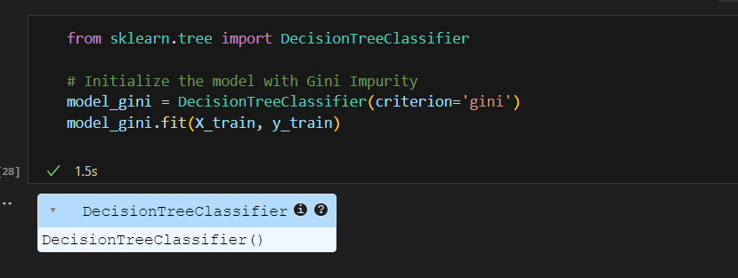

**Step-6: Train the Decision Tree Model with Information Gain(Entropy):**

**Train a decision tree classifier using Information Gain.**

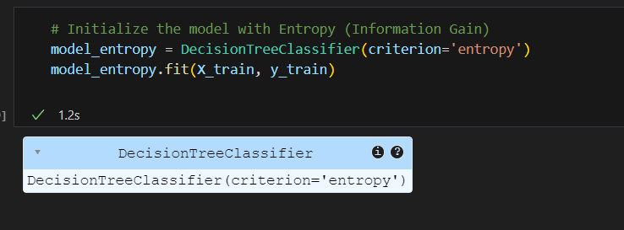

**Step-7: Evaluate the Models**

**Evaluate the performance of both models.**

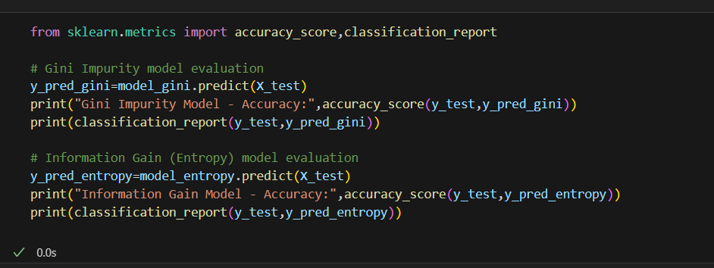

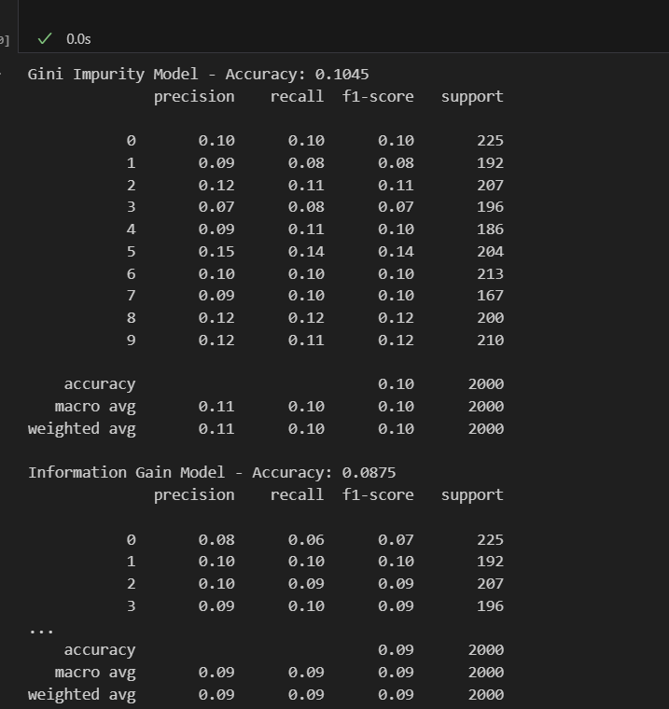

**Step-8: Pruning the Decision Tree**

**Prune the decision tree to prevent overfitting using max_depth and min_samples_split parameters.**

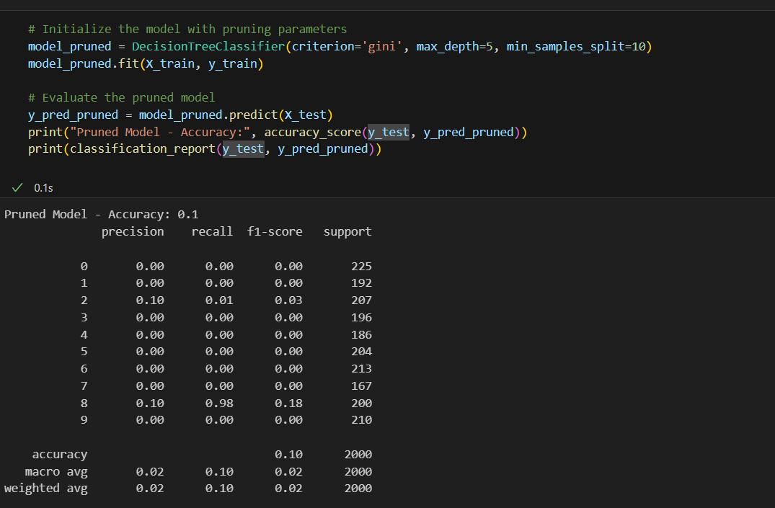

**Step-9: Visualize the Decision Tree**

**Visualize the pruned decision tree.**

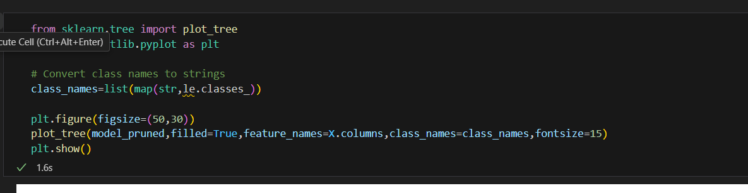

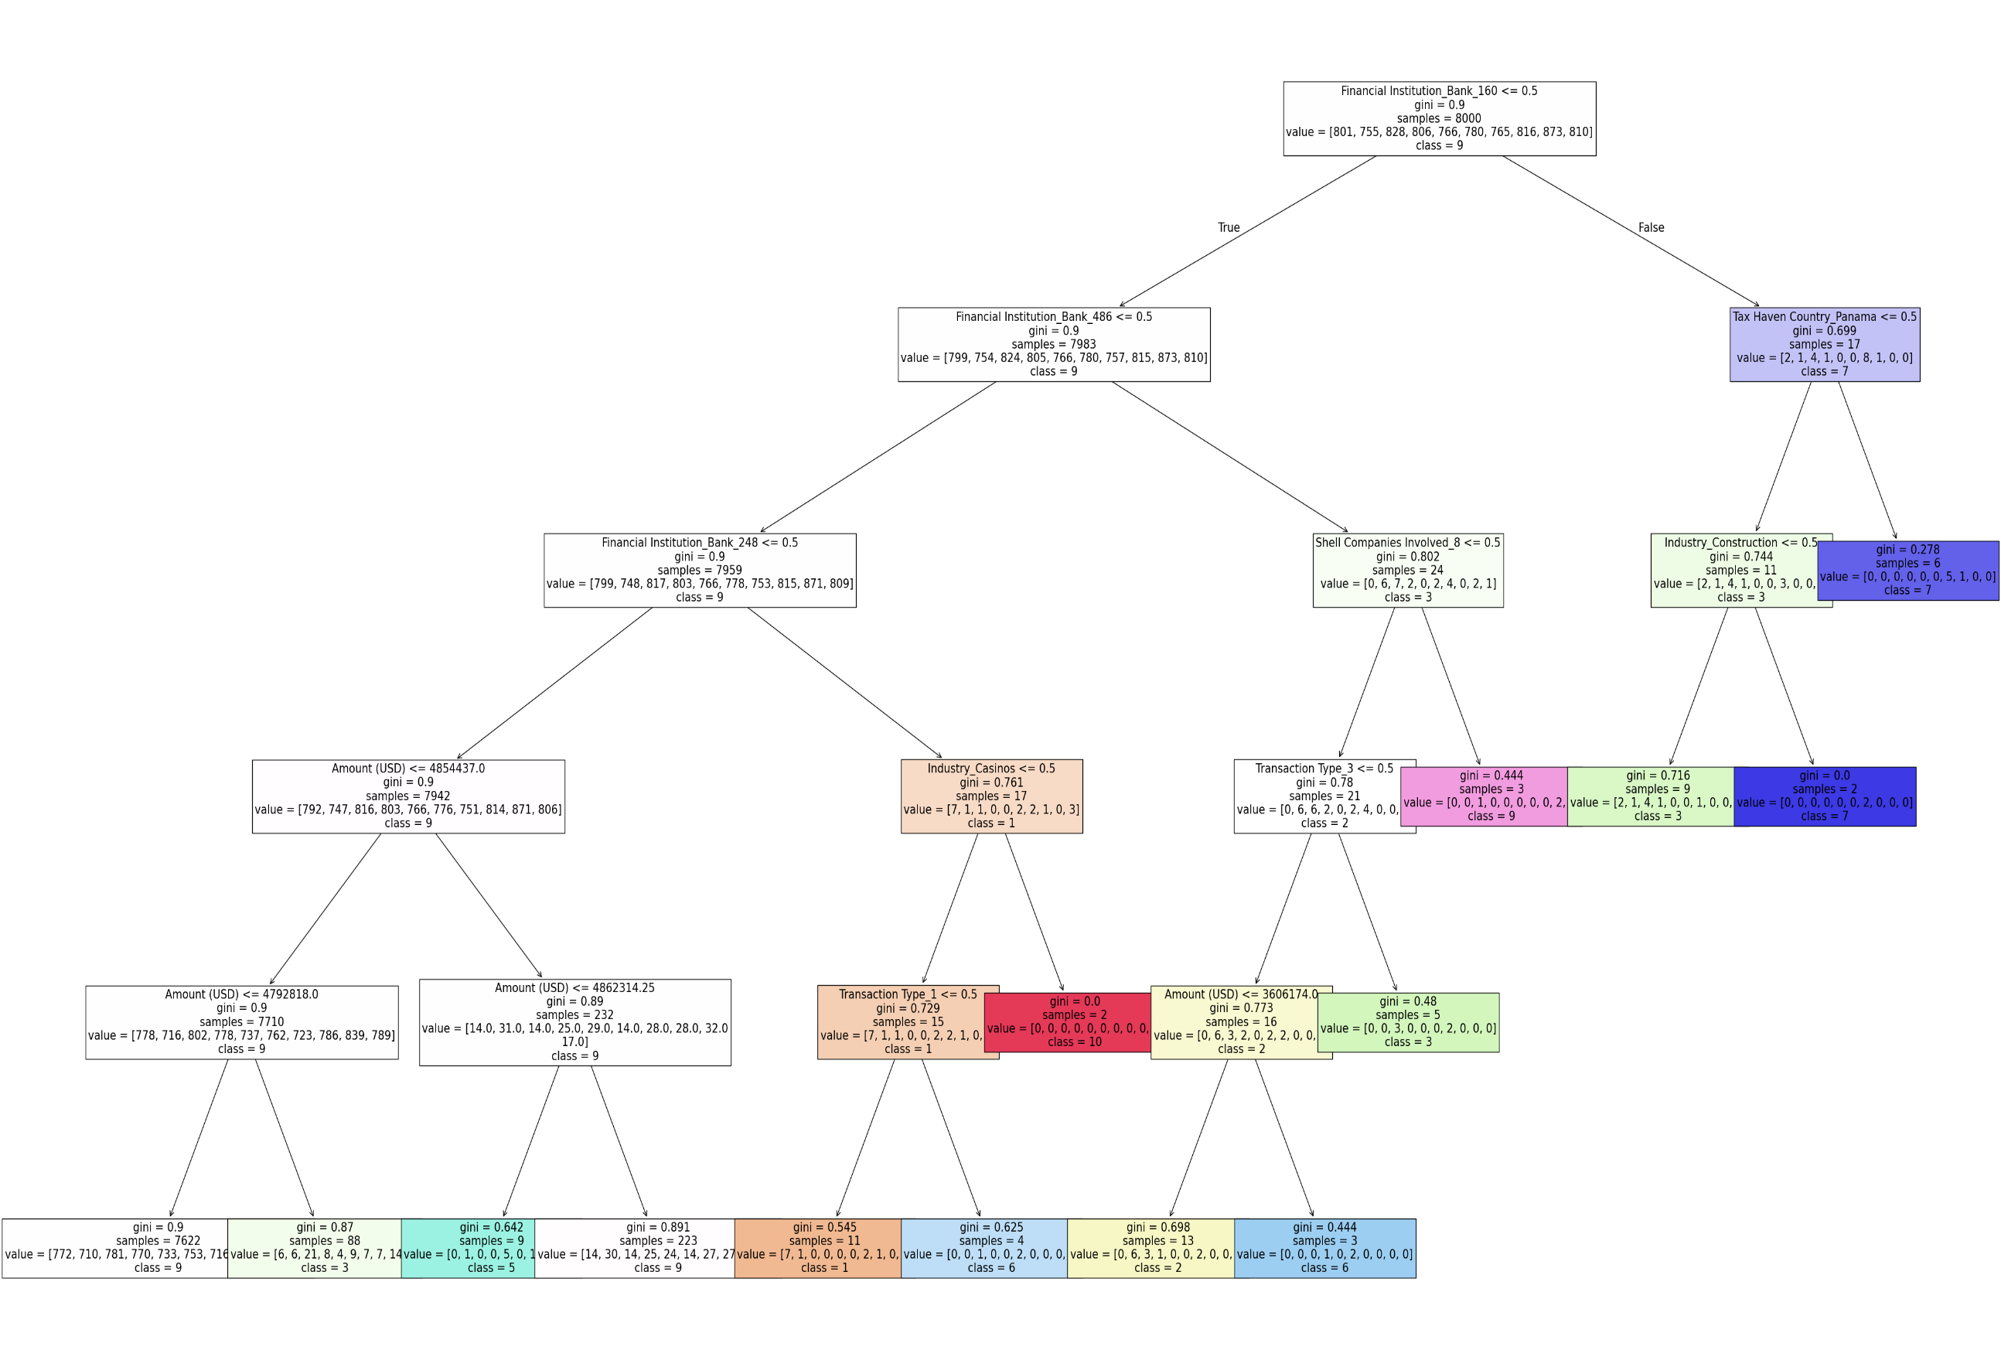

* **Email Spam Filteration-Naïve Bayes**

**Introduction:**

**Email spam filtering is a crucial task in the realm of digital communications. The objective is to correctly classify emails as either spam or non-spam (ham) to improve the user experience and ensure security. This report covers the implementation and analysis of three machine learning models—Random Forest, Naive Bayes, and Support Vector Machine (SVM)—to filter spam emails using the UCI Spambase dataset and another similar dataset.**

**Datasets Used**

1. **UCI Spambase Dataset: This dataset contains email samples labeled as spam or non-spam, with various features derived from the text.**
2. **Other Dataset: A similar dataset structured in the same format as the Spambase dataset, used for comparative analysis.**

**Let's delve into analyzing the effectiveness of Random Forest, Naive Bayes, and Support Vector Machine (SVM) classifiers in filtering spam emails across multiple datasets. Here’s a structured approach in Jupyter Notebook with the popular UCI Spambase dataset and another dataset you choose.**

**Step-1: Install Required Libraries**

**First, ensure we have the necessary libraries installed.**

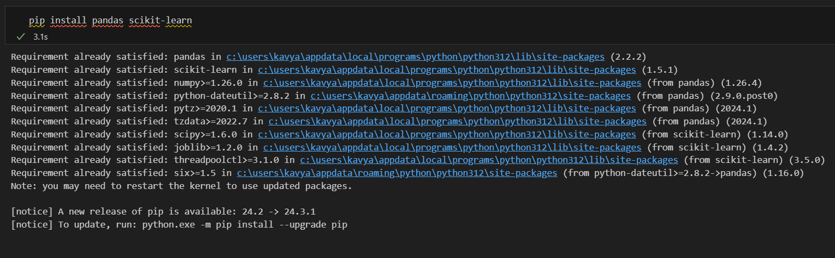

**Step-2: Load the Datasets**

**We’ll use the Spam base dataset from the UCI repository and another dataset.**

* **Loading the Data: Loading both datasets into pandas Dataframes.**
* **Setting Column Names: For better readability and feature identification**

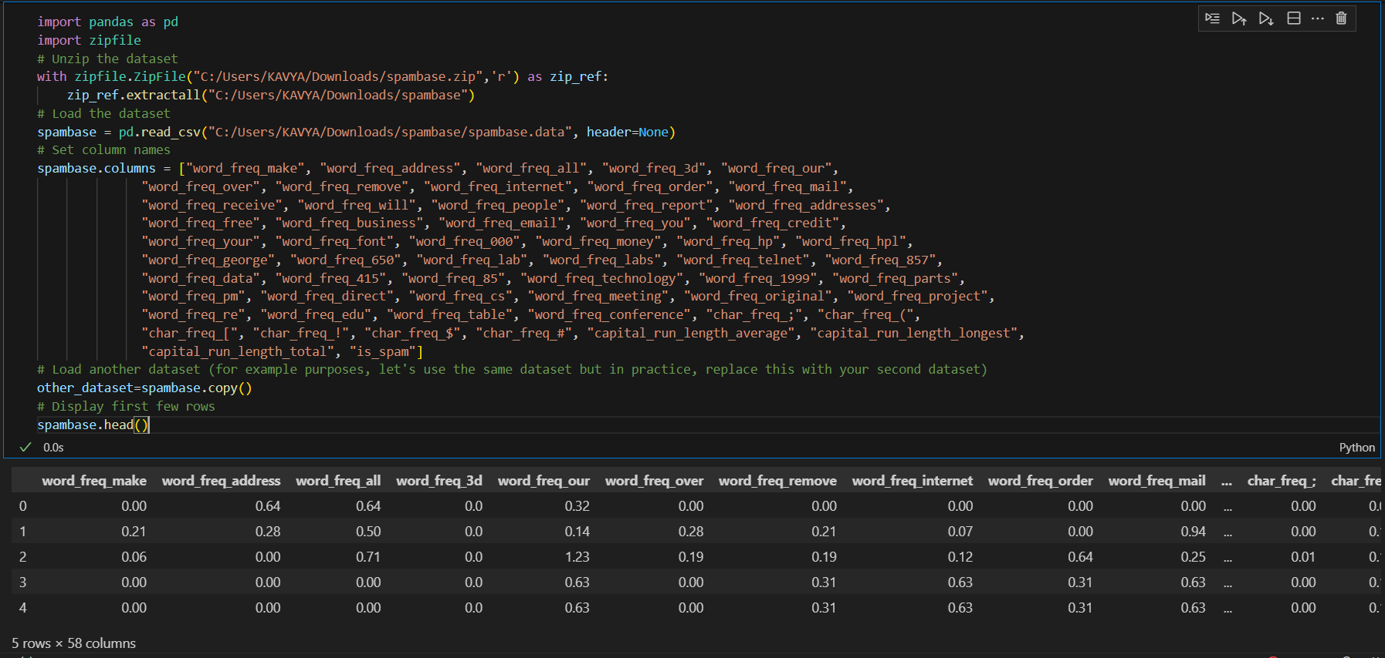

**Step-3: Preprocess the Data**

**Split both datasets into features and target variables, then into training and testing sets.**

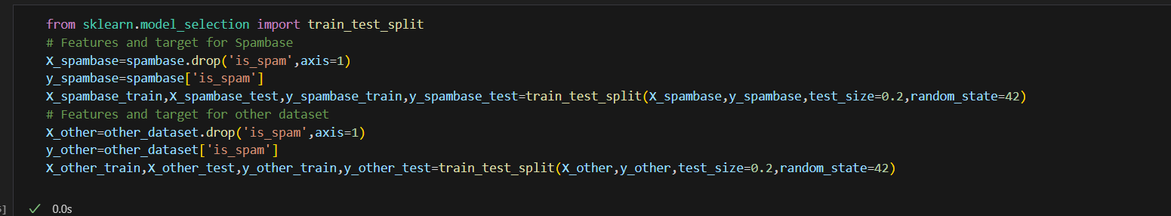

**Step-4: Train the Models**

**Train Random Forest, Naïve Bayes and SVM Classifiers**

1. **Random Forest: An ensemble learning method using multiple decision trees.**
2. **Naïve Bayes: A probabilistic classifier based on Bayes’ Theorem.**
3. **Support Vector Machine(SVM): A powerful classifier that finds the optimal boundary between classes.**

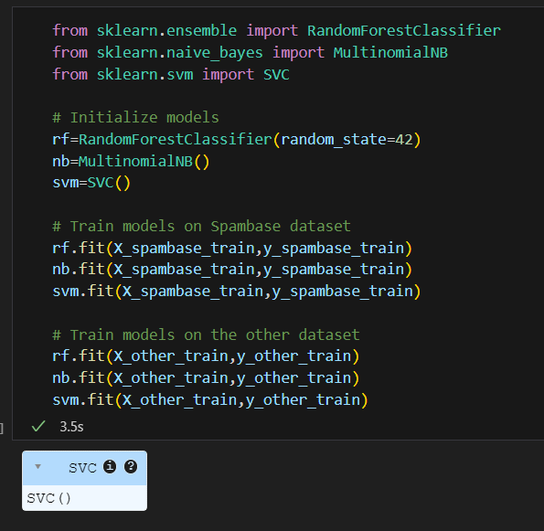

**Step-5: Evaluate the Models**

**Evaluate each model’s performance on both datasets.**

**The models were evaluated on their accuracy and other metrics such as precision, recall, and F1-score:**

1. **Accuracy: Proportion of correctly classified instances.**
2. **Precision: Proportion of true positive predictions among all positive predictions.**
3. **Recall: Proportion of true positive predictions among all actual positives.**
4. **F1-Score: Harmonic mean of precision and recall.**

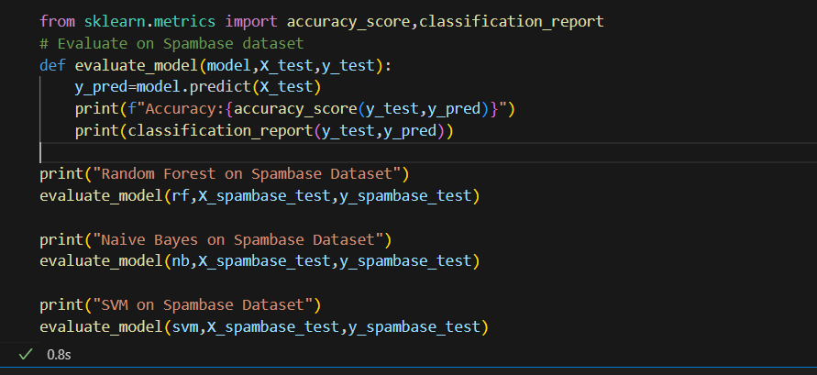

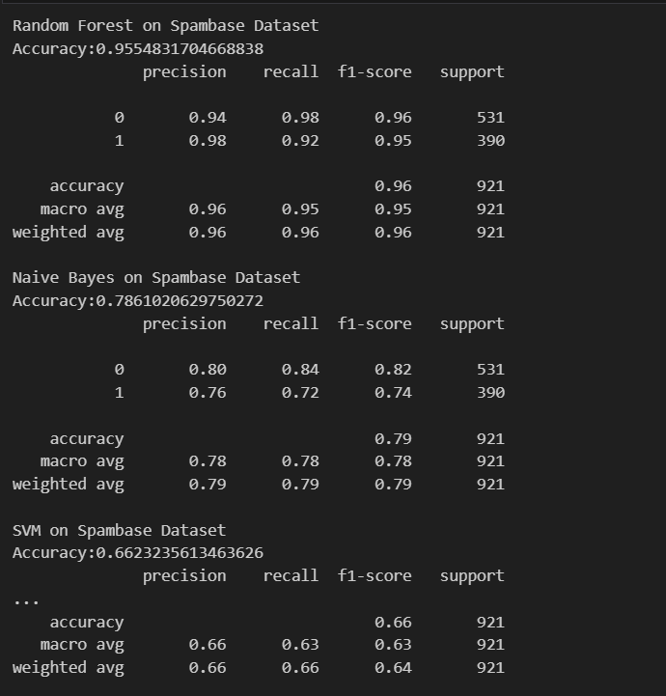

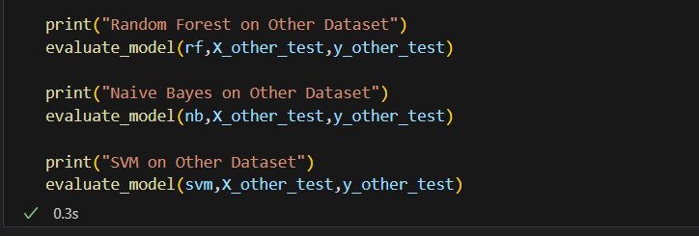

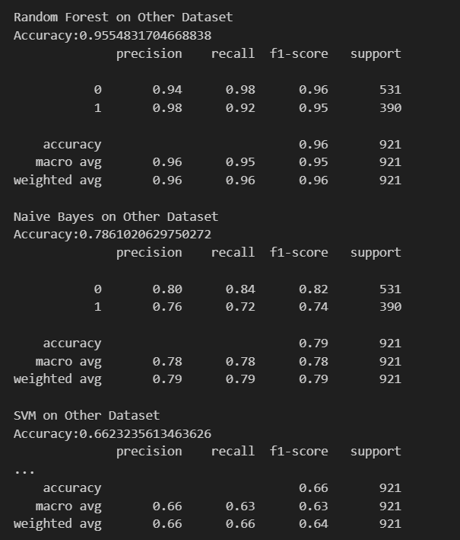

* **To determine if the emails are spam-filtered correctly, you'll evaluate the performance of your models using accuracy, precision, recall, and F1-score from the classification report. These metrics help you understand how well your models distinguish between spam and non-spam (ham) emails.**

**Step-1: Make Predictions**

**Use our trained models to predict the labels for the test datasets.**

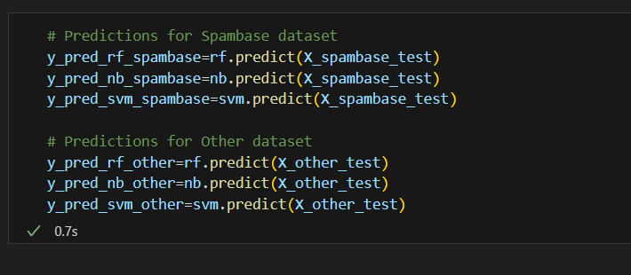

**Step-2: Evaluate Performance**

**Calculate the evaluation metrics for each model.**

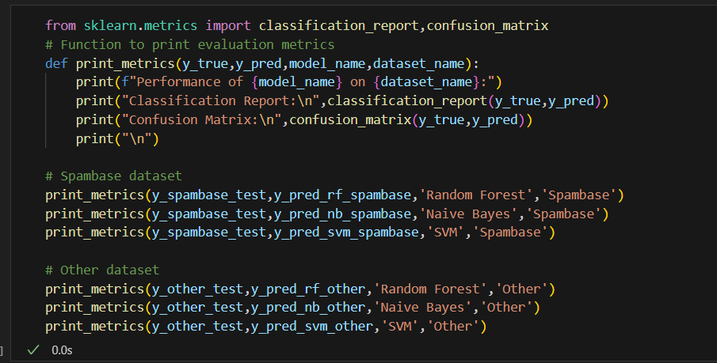

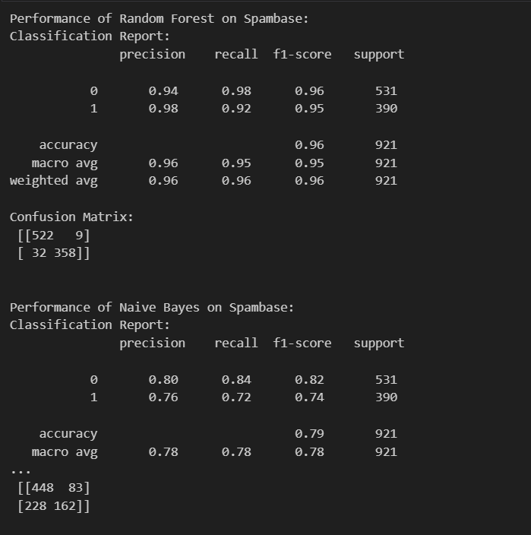

**Key Metrics:**

* **Accuracy: Overall, how often the model correctly predicts the spam/non-spam labels.**
* **Precision: Of all the emails predicted as spam, how many were actually spam.**
* **Recall: Of all the actual spam emails, how many were correctly identified.**
* **F1-score: A balance between precision and recall.**

**Interpretation:**

* **High Accuracy: Indicates the model is generally performing well.**
* **High Precision: Means that when the model predicts an email as spam, it's likely correct.**
* **High Recall: Means the model is good at detecting most spam emails.**
* **Confusion Matrix: Shows the true positives, true negatives, false positives, and false negatives, providing detailed insight into the model's performance.**

**Comparative Analysis**

**The performance of the models on both the UCI Spambase dataset and the other dataset was compared. Random Forest, Naive Bayes, and SVM were assessed to determine their effectiveness in filtering spam emails.**

**Conclusion**

**Random Forest provided a robust performance with high accuracy and balanced precision-recall. Naive Bayes excelled in situations where the feature independence assumption holds true. SVM, despite being computationally intensive, showed excellent performance in distinguishing spam from non-spam. This comparative analysis demonstrates the strength of ensemble methods and the simplicity and efficiency of Naive Bayes in spam filtering tasks.**

**By implementing and evaluating these models, we gained insights into the efficacy of different machine learning techniques in addressing spam email classification, providing a comprehensive understanding of their strengths and weaknesses.**